**MALAWI ASSEMBLIES OF GOD UNIVERSITY**

**FACULTY OF COMMERCE AND MANAGEMENT STUDIES**

**Taxi Management System Documentation: Case of Cabs365**

**By**

**Thembinkosi MacDonald Chikandira**

**(18010100114)**

**Date of submission: 22 October, 2022**

**DEDICATION**

This project is dedicated to the Almighty God for his mercy and to my entire family whose prayers and support have brought me this far.

Table of Contents

Chapter 1: Introduction 10

1.1. Project History 10

1.2. Problem Statement 11

1.3. Project Aims and Objectives 11

1.3.1. Project Aim 11

1.3.2. Project Objectives 11

1.4. Significance of the project 12

1.4.1. Security 12

1.5. Scope and Limitations 12

1.5.1. Project Scope 12

1.5.2. Project Limitations 12

1.6. System Personnel Future 12

Chapter 2: System Requirements Specifications 14

2.1. Functional requirements 14

1.7. Interface requirements 15

1.8. Non-functional requirements 15

1.8.1. System-related non-functional requirements 15

1.8.2. User related non-functional requirements 17

2. Project Plan 18

3.1. Development Cost 18

2.2. Software Life Cycle Constraints 18

2.3. System Delivery 18

2.3.1. Extent deliverables 18

2.3.2. Deliverable format 19

2.4. Installation 19

2.5. Reporting 19

2.6. Development Time 19

Chapter 3: Detailed Design Document (DDD) 20

4.1. Goals and objectives 20

4.2. Scope of Solution 20

4.2.1. Registration of system users and distributors 20

4.2.2. Authenticating users 20

4.2.3. Management of health products 20

4.2.4. Management of orders 20

4.2.5. Generation of reports 21

4.3. Constraints 21

4.3.1. Hardware 21

4.3.2. Software 21

4.4. Architectural and Component-Level Design 21

4.4.1. Use Case Diagram 22

4.4.2. Activity Diagrams 23

4.4.3. Class Diagram 26

4.4.4. Sequence Diagrams 27

4.5. Database Schema 29

4.5.1. Booking List 29

4.5.2. Cab List 29

4.5.3. Category List 30

4.5.4. Client List 30

4.5.5. System Info 30

4.5.6. Users List 31

4.6. Graphical User Interface 31

4.6.1. Homepage 31

4.6.2. Client Registration Page 32

4.6.3. Driver Login 32

4.6.4. Client Booking a Cab 33

4.6.5. Driver Homepage 34

4.6.6. Driver Views Booking Details 34

4.6.7. Administrator Homepage 35

4.6.8. Administrator Manage Clients 35

4.6.9. Administrator Manage Cabs 36

4.6.10. Administrator Manage Bookings 36

4.6.11. Administrator Manage Users 37

4.6.12. Administrator Manage Website 37

4.7. Objects and Actions 38

4.7.1. Home Screen 38

4.7.2. Client Screen 38

4.7.3. Administrator Screen 38

4.7.4. Driver Screen 38

5. Quality Assurance 38

5.1. Detailed test plans 38

Chapter 4: User Manual 40

5.2. Installation 40

5.2.1. Installation of Google Chrome Browser 40

5.2.2. XammpServer Installation and Configuration 40

Chapter 5: Project Report 85

6. Contact Details (for assistance) 85

7. Appendix 86

References 87

**PLAGIARISM DECLARATION**

I, **Thembinkosi MacDonald Chikandira** hereby declare this project titled “Taxi Management System: Case of Cabs365” is a project of my own efforts, undertaken under the supervision of Stephen Kalisha and has not been presented and will not be presented elsewhere for the award of a degree or certificate. All sources have been duly acknowledged.

THEMBINNKOSI MACDONALD CHIKANDIRA

(18010100114)

______________________ _______________________

SIGNATURE DATE

**ACADEMIC APPROVAL**

In accordance with Malawi Assemblies of God University (MAGU) policies, this thesis is accepted in partial fulfillment of the requirements of the award of Bachelors Degree in Commerce: Business Information Systems.

Ms. Pamela Mubbunu

______________________________ ______________________________

Dean of Faculty of Commerce DATE

**ACKNOWLEDGEMENTS**

I would like to express my profound and absolute gratitude and thanks to Almighty God for having made it possible for me to see the writing of this Project logically and successfully. My sincerest gratitude goes to my able supervisor Stephen Kalisha who gave me his kind and energetic effort throughout this project. I am also grateful to my family for the tremendous effort, assistance, encouragement, support and guidance they gave me throughout the writing of this Project irrespective of their busy schedule, May god continue to bless you.

**List Of Figures**

Figure 1…………………………………………………… Gannt Chart showing project timeline

Figure 2………………………………………………………………………… Use Case Diagram

Figure 3……………………………………………………………………… Cab Search Diagram

Figure 4…………………………………………………………………... Login Activity Diagram

Figure 5……………………………………………………………. Registration Activity Diagram

Figure 6…………………………………………………………………………….. Class Diagram

Figure 7…………………………………………………………………. Login Sequence Diagram

Figure 8…………………………………………………………... Registration Sequence Diagram

Figure 9……………………………………………………………………... Booking List Schema

Figure 10…………………………………………………………………………. Cab List Schema

Figure 11……………………………………………………………………. Category List Schema

Figure 12………………………………………………………………………. Client List Schema

Figure 13…………………………………………………………………….. System Info Schema

Figure 14………………………………………………………………………… User List Schema

Figure 15………………………………………………………………………………. Homepage

Figure 16………………………………………………………………………. Client Registration

Figure 17……………………………………………………………………………... Driver Login

Figure 18……………………………………………………………………. Client Booking a Cab

Figure 19………………………………………………………………………... Driver Homepage

Figure 20……………………………………………………………………… Driver View Details

Figure 21………………………………………………………………………. Admin Homepage

Figure 22………………………………………………………………….. Admin Manage Clients

Figure 23…………………………………………………………………….. Admin Manage Cabs

Figure 24……………………………………………………………….. Admin Manage Bookings

Figure 25…………………………………………………………………… Admin Manage Users

Figure 26………………………………………………………………… Admin Manage Website

Figure 27………………………………………………………………………………. Homepage

Figure 28………………………………………………………………………………. Homepage

Figure 29…………………………………………………………………..…... Admin Homepage

Figure 30………………………………………………………………………… Admin add driver

Figure 31…………………………………………………………………. Admin Manage Website

Figure 32…………………………………………………………… Admin View Booking Details

Figure 33………………………………………………………………… Admin Manage Account

Figure 34………………………………………………………………………………. Homepage

Figure 35………………………………………………………………………. Client Registration

**List of Tables**

Table 1…………………………………………………………………... Functional Requirements

Table 2……………………………………………………………………..Interface Requirements

Table 3…………………………………………………………………………. Development Cost

**List of Abbreviations**

TMS - Taxi Management System

DB – Database

**Glossary**

|  |  |
| --- | --- |
| **Term** | **Definition** |
| Database | A collection of related data |
| Administrator | A person who controls the system |
| Driver | A person who drives the taxi |
| TMS | Taxi Management System |
| Non-functional Requirements | Requirements which impose constraints on the design or implementation (such as performance, quality standards, or design constraints) |
| DDD (Detailed design document) | A document that gives details on how the solution will be implemented |
| SRS (Software requirements specification) | A document that outlines the requirements and specifications of a system |
| Functional requirements | A requirement that describes a service provided by a system |
| ID | A key that identifies an entity in the database uniquely |

*ABSTRACT*

This is a design and implementation of an online taxi management system (TMS). The online taxi booking system is designed to reflect the manual taxi booking system by automating it, which would eliminate the many problems and errors encountered in the manual booking system. The technologies used in the development of this system include HTML, PHP, SQL, Javascript, and CSS.

# Chapter 1: Introduction

## Project History

The taxi and car hire industry has evidently been ignored in the IT industry as little has been done to regulate its operations in big markets within Africa. The main focus in this project is to show how the automation of the taxi business may bring sanity as well as reducing insecurity and tracking the taxation gains to the government (Flores-Guri, 2003). Taxi and car hire reservations businesses have typically ranked high as one of the most popular items to be bought online.

Online taxi and car hire booking is the obvious option for travelers within the city due to the nature incidences associated with the business. With the new system in place, Consumers now

have greater access to information regarding the taxi and car hire services within the city and outside (Yang, Choudhury and Carvalho, 2009). With the introduction of the online system, the people of Zomba are able to see competitive prices, view pictures of the cars, routes, and drivers.

Though many Web-based systems are in use now and many of us and the entire world rely on them, the way in which they are developed raises serious distresses. They need to be reliable

and perform well at all times (Booz, 2003). Web-based system developers need a sound methodology, a disciplined process and a set of good guidelines. Due to the high number of new demands, Web applications are evolving fast and the complication of these systems is rapidly increasing.

Many online taxi and car hire systems are Web-based applications that are distributed and accessed using a Web browser across the globe. During recent years the extent and scope of their use has grown rapidly, significantly affecting all aspects of our lives in the transport industry (Frankena and Pautler, 1984). Even traditional legacy systems have migrated to the Web; The scope and complexity of current Web applications varies widely: from small-scale, short-lived services to large-scale enterprise applications distributed across the Internet and corporate intranets and extranets.

An Online taxi and car hire information system will offer Cabs365 organization a mechanism to book, cars (taxi’s) online through the use of internet anytime around the clock within the city of Zomba from the comfort of their homes. The organization has its own fleet of cars and customers both local and international. These customers will be able to make reservations directly in the online system, from any workstation connected to the Internet, anywhere in the world.

The organization has its own trusted drivers who manage and operate the vehicles and are

paid a salary at the end of the month. all payments are to be done to the drivers after safely arriving at the chosen destination.

Most people in Zomba use cabs for their daily transportation needs. The company must be registered and fulfils all the requirements and security standards set by the taxi association and the road traffic directorate.

The platform would offer an administration interface where the taxi company can manage the content, and access all bookings and customer information. Hiring a taxi assists people to go

around even when they do not have access to their own personal vehicle or don't own a vehicle at all.

## Problem Statement

At the moment Cabs365 has no system that manages the taxi and car hire services. The taxi and car hire business at Cabs365 is all manually and unprofessionally done; the customers pick any taxi /car along the roads and negotiate for the price and other costs without considering risks and uncertainties that may be involved. This at times results to serious security and conmen cases where innocent customers are attacked, conned or even killed by the dubious taxi operators who end up untraced as their details are not captured anywhere and no one can tell which vehicle was used.

## Project Aims and Objectives

### Project Aim

Design, Develop and implement an online automated taxi hire and management system to manage the Cabs365 taxi business based on simulated data of such taxi operations.

### Project Objectives

1. Collection of data about the existing system if any and the challenges the Cabs365 customers face.
2. From point one, create the requirements specifications of what the new system is made to do.
3. Develop physical and logical models of the new system to be developed.
4. Coding and programming the online automated system for managing the taxi business of Cabs365.
5. Testing the system after completing its physical development.
6. Develop a user manual for the system.
7. Documenting the final report for the complete system.

## Significance of the project

By introducing an Online Taxi Management System for Cabs365 the following issues and concerns will be addressed:

### Security

As any driver can operate the Taxi business, this has resulted to serious crime issues e.g., mugging of innocent passengers and/or drivers by luring them to places they don’t know, at the end the passengers and/or drivers are not able to trace who the taxi driver or the passenger was as there are no records.

## Scope and Limitations

### Project Scope

Develop and document an online automated system to manage the taxi services for Cabs365 in Zomba and Malawi at large; that will enable customers do online bookings and reservations using online web services. The system will manage and track all the drivers, and cars as well as helping to curb insecurity within the city. By the use of the online system, customers will be picked at designated places and customer accounts will help identify themselves to the taxi operators.

### Project Limitations

The project will be limited to creation of an interface to register for car reservation/booking and creation of a database which then will store customer data. The company is limited to only people located in Zomba. PHP Technology used for the development and execution of the application.

## System Personnel Future

TMS is proposed for Cabs365 based in Zomba. The Manager (Administrator), Driver(s), and Clients will be the users of the system. The Manager is the one responsible for adding users of the system as well as assigning a client’s booking to a driver.

The Driver is responsible for accepting an assigned booking if they are available at the time or declining it is they are not. The client shall be able to book a taxi and also request for reports of their previous bookings.

The TMS is proposed by **Thembinkosi Chikandira**, as a fulfilment requirement for the award of Bachelor of Commerce in Information Systems. The system will be used by Cabs365 to support their daily operations.

# Chapter 2: System Requirements Specifications

The requirements are the descriptions of the system services and constraints that are generated during the requirements engineering process.

This section contains the functional requirements which are statements of services the system should provide, how the system should react to particular inputs and how the system should behave in particular situations. Non-functional requirements are constraints on the services or functions offered by the system and interface requirements of the system. It gives a detailed description of software requirements identified during the systems analysis.

## 2.1. Functional requirements

|  |  |  |
| --- | --- | --- |
| **Req. No** | **Requirement** | **Description** |
| 1 | User registration | The system shall allow customers to be registered so that they are recognized by the taxi service company.  The Administrator shall be able to register new users like drivers, and clients. |
| 2 | Allow only authorized users | The system shall allow only authorized users to  access it. Users will be required to enter their usernames and passwords to access the system and  access will be denied for all wrong login details. |
| 3 | Taxi Management | The system shall manage taxis which  will include adding and removing taxis, as well as changing the drivers assigned to a particular taxi. |
| 4 | The system shall manage bookings | The customer/client shall be able to make bookings for a taxi and every order that has been made will be recorded in the system. |
| 5 | Notifying customers and staff members | The system shall be able to notify the customer  about registration, benefits through SMS. The system shall also be able to give notification to drivers if they have been assigned to a certain. |
| 6 | Produce monthly report | The system shall produce reports upon request |

## Interface requirements

The system will not interface with any other system

|  |  |  |
| --- | --- | --- |
| **Req No.** | **Requirements** | **Description** |
| 1 | The system shall maintain unique details of user | The system shall generate unique IDs which will be used to present unique details of users |
| 2 | The system shall allow users to login with username and password. | The system shall produce an alert or warning dialogue box once wrong or invalid login credentials have been entered. |
| 3 | The Administrator shall add, update and delete user details in the system | The administrator shall enter users’ information into the system during user addition e.g., password, username. |

* 1. Non-functional requirements

Non-functional requirements are constraints on the services or functions offered by the system, these are grouped into system related non-functional requirements and user related non-functional requirements. These aspects include system performance, costs and such general system characteristics as reliability, security and portability.

* + 1. System-related non-functional requirements

1. Performance
   1. Time
      1. The system shall give fast response to the user and the speed will depend on the network connection speed and the type of machine the system is running on.
2. Space
   1. The system shall require a minimum of 2 Gigabytes of space.
3. Operational Environment
   1. Hardware platform
      1. A server which will host the system and client computer that will be used by various users to access the system will be required. The client computer with minimum of Pentium IV processor, 300MHz, 2 GB RAM.
4. Software platform
   1. The system will need a host machine which is compatible with software like MySQL and PHP. Because the system will run on many different software platforms like windows XP, windows Vista, windows 7, windows 8, windows 8.1, windows 10, windows 11 and Linux.
5. Standards conformance
   1. The TMS will follow existing standards and regulations stated by the MAGU.
6. General characteristics
   1. Reliability
      1. The condition of the machine will determine the reliability of the system. The system will be monitored and checked frequently to make sure that it is always in operation. The computer hosting the system will be fixed with a (UPS) to avoid data lose during a black-out. In the event that a server has crashed, a backup server will be up and running within the hour.
   2. Data accuracy
      1. To ensure data accuracy the system will have data validation mechanism to ensure that only correct information is fed into the database and to ensure data integrity
   3. Security
      1. To ensure security users will be able to access only their own personal information and not that of other users. The system will only allow authorized users to log into the system by providing valid usernames and passwords.
   4. Privacy
      1. The system will have different user privileges that will allow users to access only their own personal information and not that of other users. For example, a student cannot access a lecturer’s information
   5. Safety
      1. To ensure safety, the system data or database will regularly be backed up on separate machine in case of some emergences such as system crush, fire, theft of computer server.
   6. Robustness
      1. The system will be decentralized and therefore more robust against the failure of single components, for instance, if one server fails a backup server will be up and running within an hour.
   7. Portability
      1. The system will run on different platforms such as Windows and Linux that can run PHP, Apache server and MYSQL. It will be possible for users to access the system using different types of machines because it is a web-based application.
   8. Modifiability and Extensibility
      1. As need arises to expand the system or to make some improvements, the system has room for that. The system will be modifiable and extensible to meet new requirements, that is, any updates or upgrades will be made on the servers without affecting the users.

### User related non-functional requirements

* skill levels
  + Users of this system shall require some basic knowledge of Computers.
  + The developer of the system shall conduct training lessons to its users to demonstrate on how to use the system and how it works.

# Project Plan

The project plan gives an outline of expenses to be incurred throughout the development of the System and the whole project.

## 3.1. Development Cost

**Project Budget**

|  |  |  |
| --- | --- | --- |
| **Item** | **Quantity** | **Cost** |
| Computer | 1 | K250,000 |
| Transport | undefined | K22,000 |
| Plain papers | 1 ream | K5,500 |
| Airtime | undefined | K8,000 |
| Printing | undefined | K9,000 |
| Internet | undefined | K19,000 |
| **Total** | undefined | K313,500 |

## Software Life Cycle Constraints

During the system development life cycle, there might be some problems that can be met along the way. Firstly, end-user training after system implementation. Secondly new technology, and as a developer I may need to learn new unfamiliar programming languages like Ajax which will need time to study.

## System Delivery

### Extent deliverables

The running system will be delivered first for user testing and user manuals will follow which will help in training users.

### Deliverable format

The system will be in php format in a .zip file and user manuals will be in .PDF, .doc and .txt format

## Installation

The system implementation would require the authorization of the Cabs365 authorities in order for the developer to implement the system to the existing filing system.

The Cabs365 TMS is not going to entirely replace the current system. It will run in parallel with the current system until all requirements are met.

## Reporting

The system will produce reports upon user range duration specification.

## Development Time

The system will take six months from the beginning to implementation

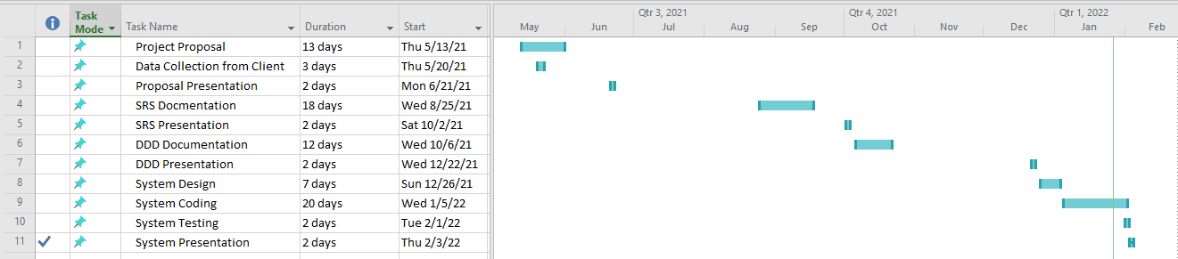

Figure 1 Gannt Chart showing project timeline

# Chapter 3: Detailed Design Document (DDD)

## 4.1. Goals and objectives

The main goal of Cabs365 Taxi Management System is to improve the management of the day-to-day business by keeping track of all taxis owned by Cabs365, their drivers as well as their registered customers.

The following are the objectives of the system:

* Keeping track of taxis owned by Cabs365
* Keeping track of booking made by clients
* Keeping track of records
* Keeping track of driver activity
* To ease generation of reports

## 4.2. Scope of Solution

Cabs365 Taxi Management System is a web-based system and will be accessed through network. The scope of solution is as follows:

### 4.2.1. Registration of system users and distributors

The system shall allow the Administrator to add and or delete accounts of users like the driver. The system shall also allow clients to register.

### 4.2.2. Authenticating users

The system shall validate all user details in order for each user to have access to the system. The system shall allow only authorized users to access it. Users will be required to enter their usernames and passwords to access the system and access will be denied for all wrong login details.

### 4.2.3. Management of health products

The system shall manage all the taxis owned by Cabs365. It shall be able to add new taxis and also remove those that are no longer owned by the business.

### 4.2.4. Management of orders

The client shall be able to make bookings or reservations for a taxi and every order that has been issued by been accepted by the administrator will be recorded in the system. This module will be able also allocate a particular booking to a particular driver.

### 4.2.5. Generation of reports

The proposed system shall produce reports upon request by the client, driver, and the administrator.

## 4.3. Constraints

For the system to work as expected should meet the following recommended specifications in terms of hardware and software.

### 4.3.1. Hardware

The network has to be more reliable as its failure can cause the whole system unusable, thus, the system may run slower or not work at all. The client computer shall run better with minimum of Pentium IV processor, 300MHz, 1GB RAM.

### 4.3.2. Software

The system will run on XP service pack 3 or higher operating systems such as windows Vista, windows 7, windows 8, windows 8.1, windows 10 and Linux. The lower versions of operating system can negatively affect the performance of the system.

## 4.4. Architectural and Component-Level Design

TMS is a web-based system and the data will be on web server. staff members and clients will be accessing the TMS from their computers and phones through the internet. The system is composed of five processes namely: manage user, authenticate user, manage taxi, manage booking, and generate report.

### 4.4.1. Use Case Diagram

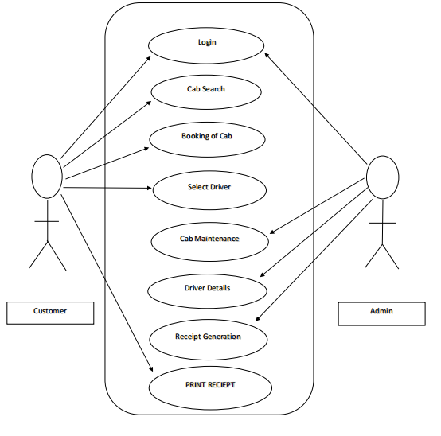

Figure 2:Use Case Diagram

### 4.4.2. Activity Diagrams

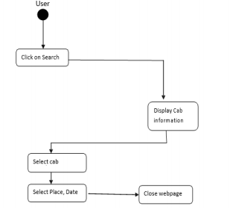

Figure 3: Cab Search Activity Diagram

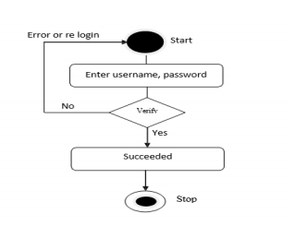

Figure 4: Login Activity Diagram

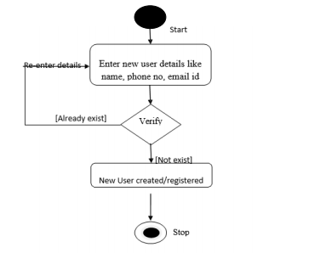

Figure 5:Registration Activity Diagram

### 4.4.3. Class Diagram

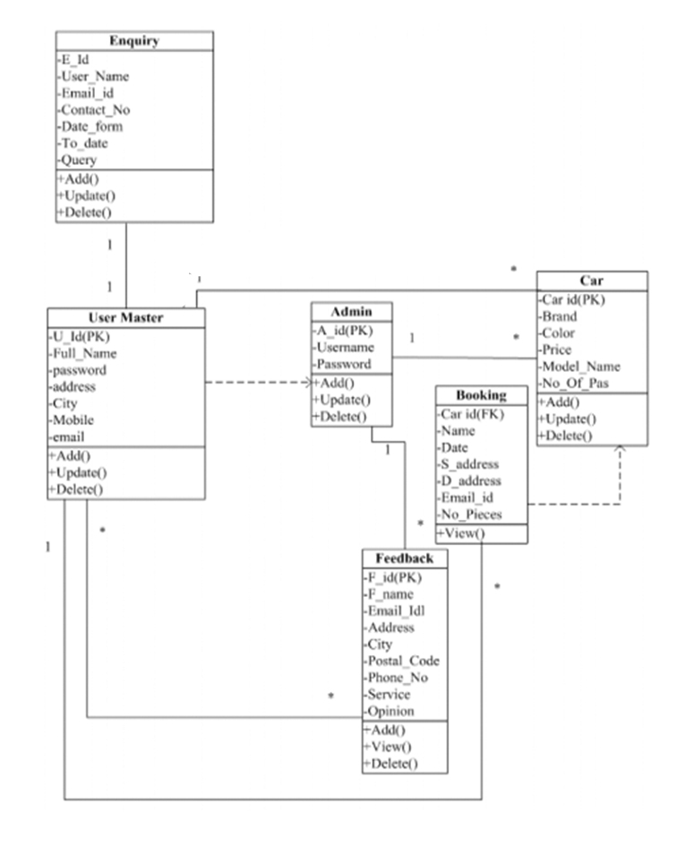

Figure 6: Class Diagram

### 4.4.4. Sequence Diagrams

Below are sequence diagrams showing show a user login and registers into the system.

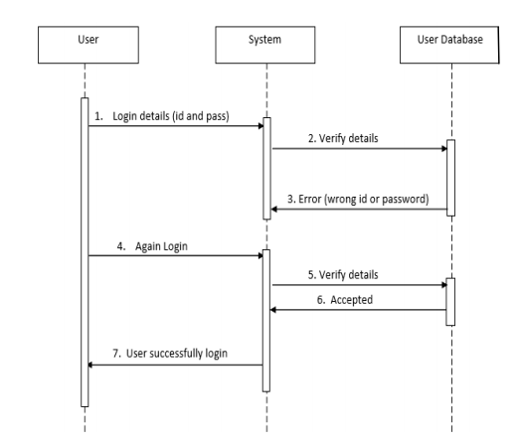

Figure 7: Login Sequence Diagram

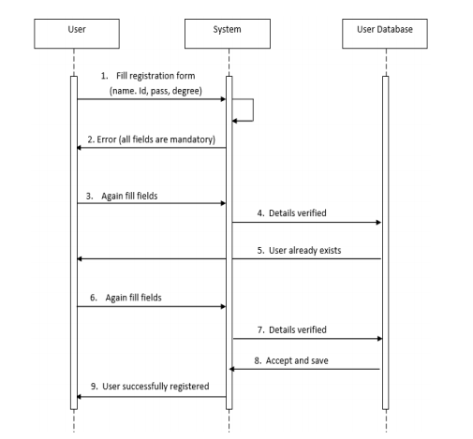

Figure 8: Registration Sequence Diagram

## 4.5. Database Schema

### 4.5.1. Booking List

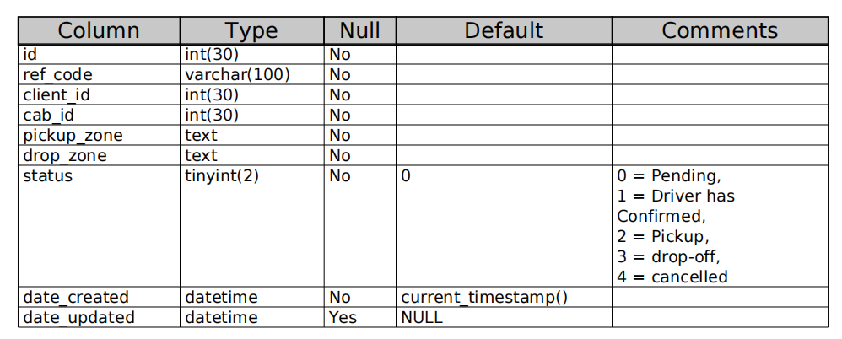

Figure 9 Booking List

### 4.5.2. Cab List

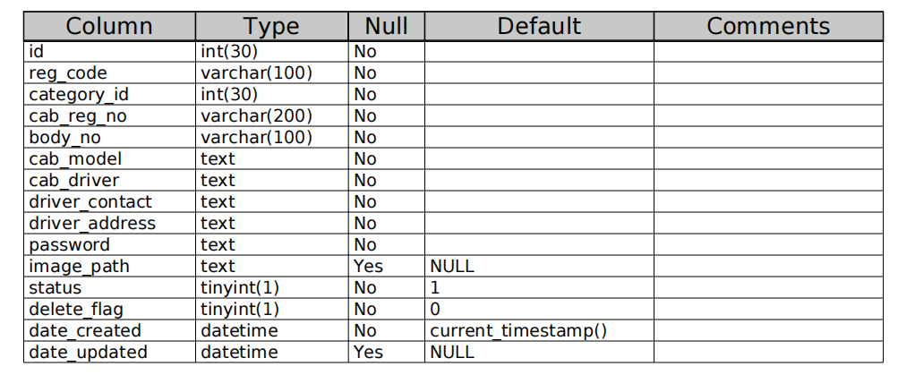

Figure 10 Cab List

### 4.5.3. Category List

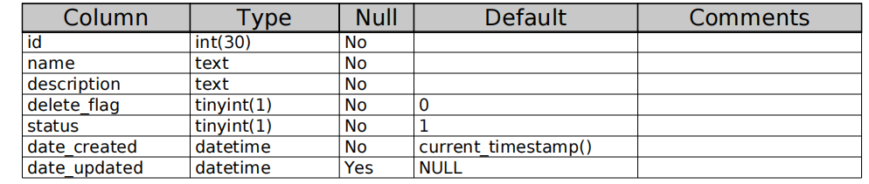

Figure 11 : Category List

### 4.5.4. Client List

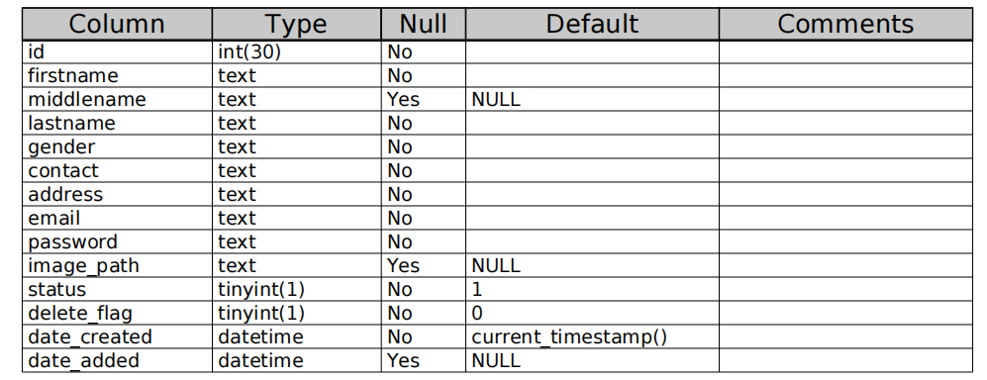

Figure 12 : Client List

### 4.5.5. System Info

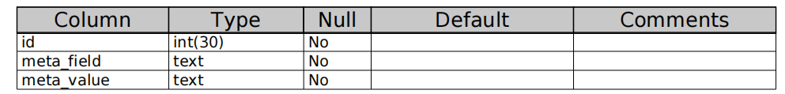

Figure 13: System Information

### 4.5.6. Users List

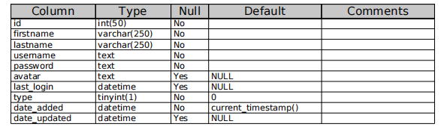

Figure 14: User List

## 4.6. Graphical User Interface

### 4.6.1. Homepage

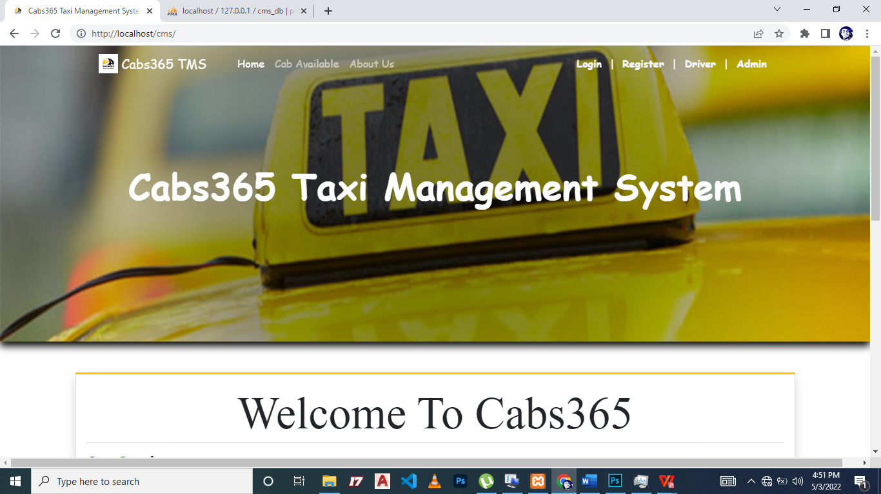

Figure 15: Homepage

### 4.6.2. Client Registration Page

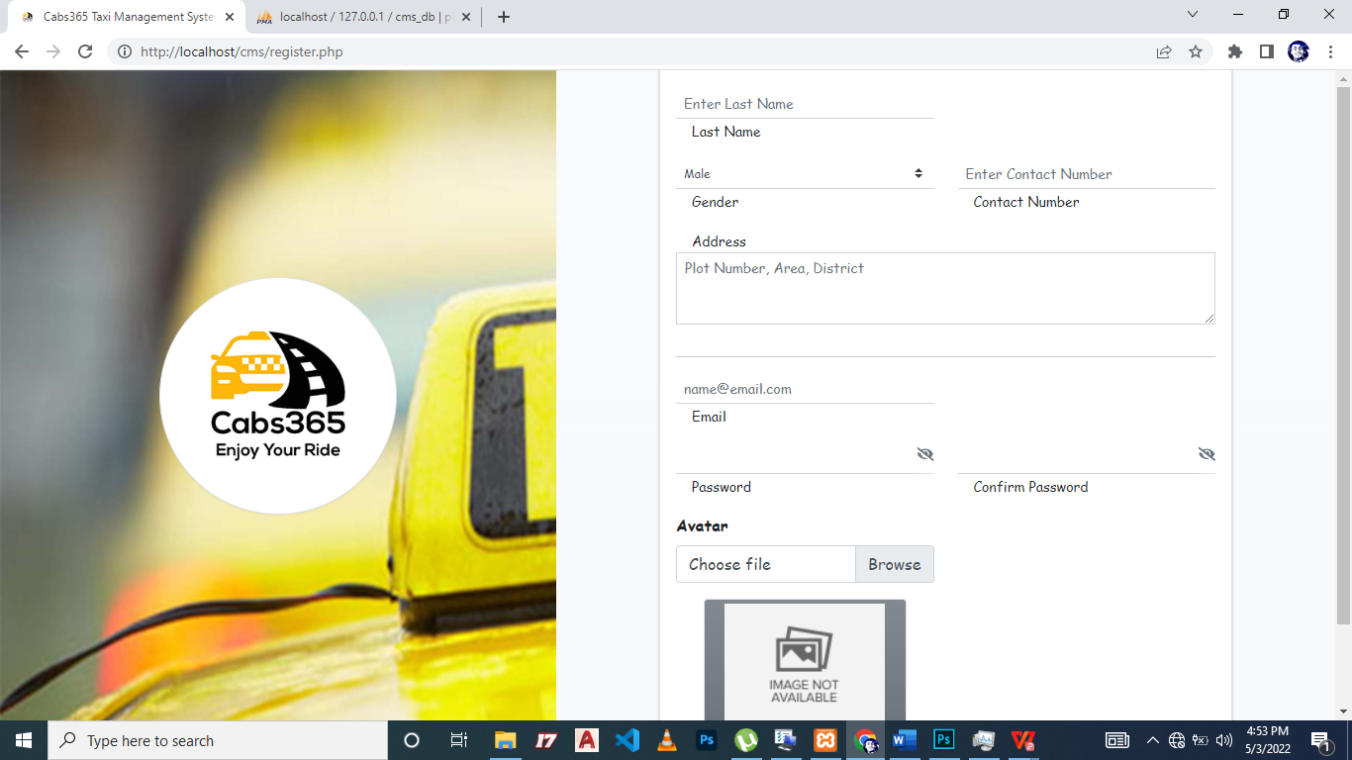

Figure 16: Client Registration Page

### 4.6.3. Driver Login

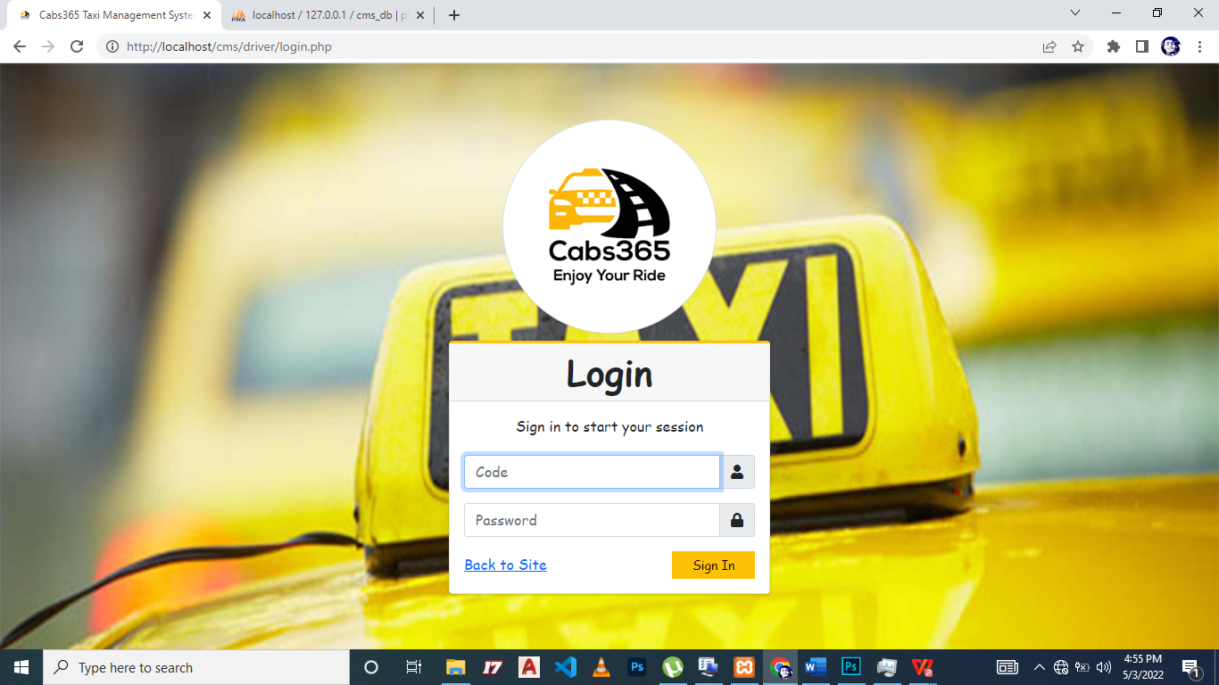

Figure 17: Driver Login

### 4.6.4. Client Booking a Cab

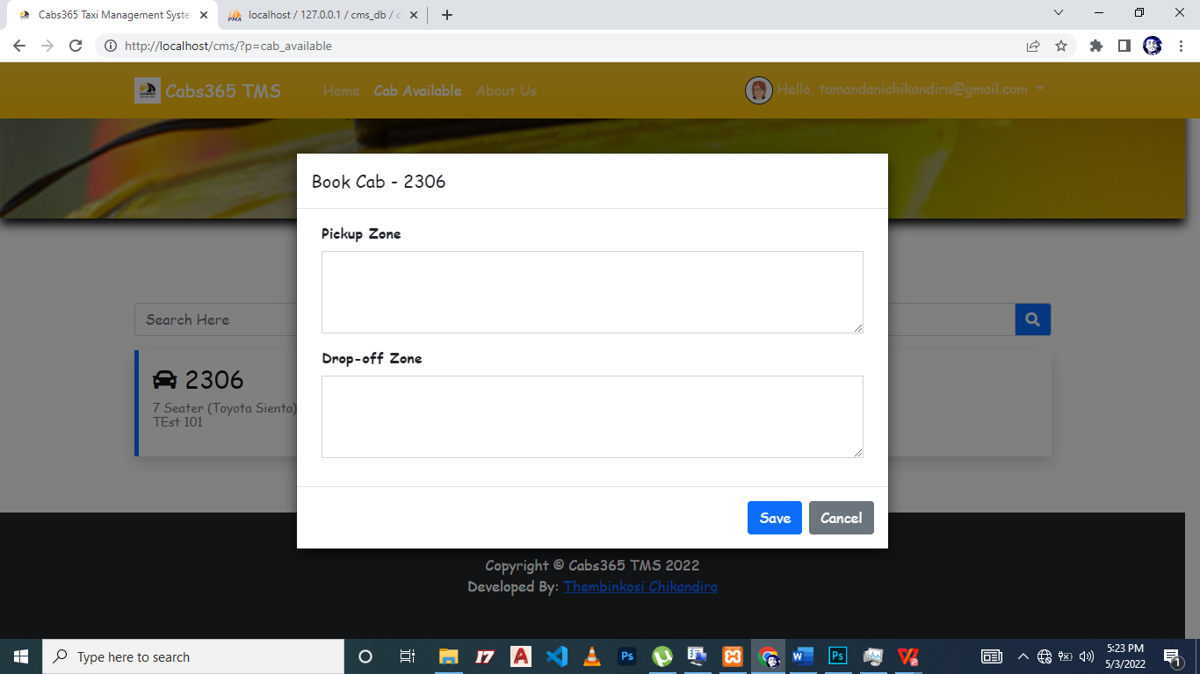

Figure 18: Client Booking a Cab

### 4.6.5. Driver Homepage

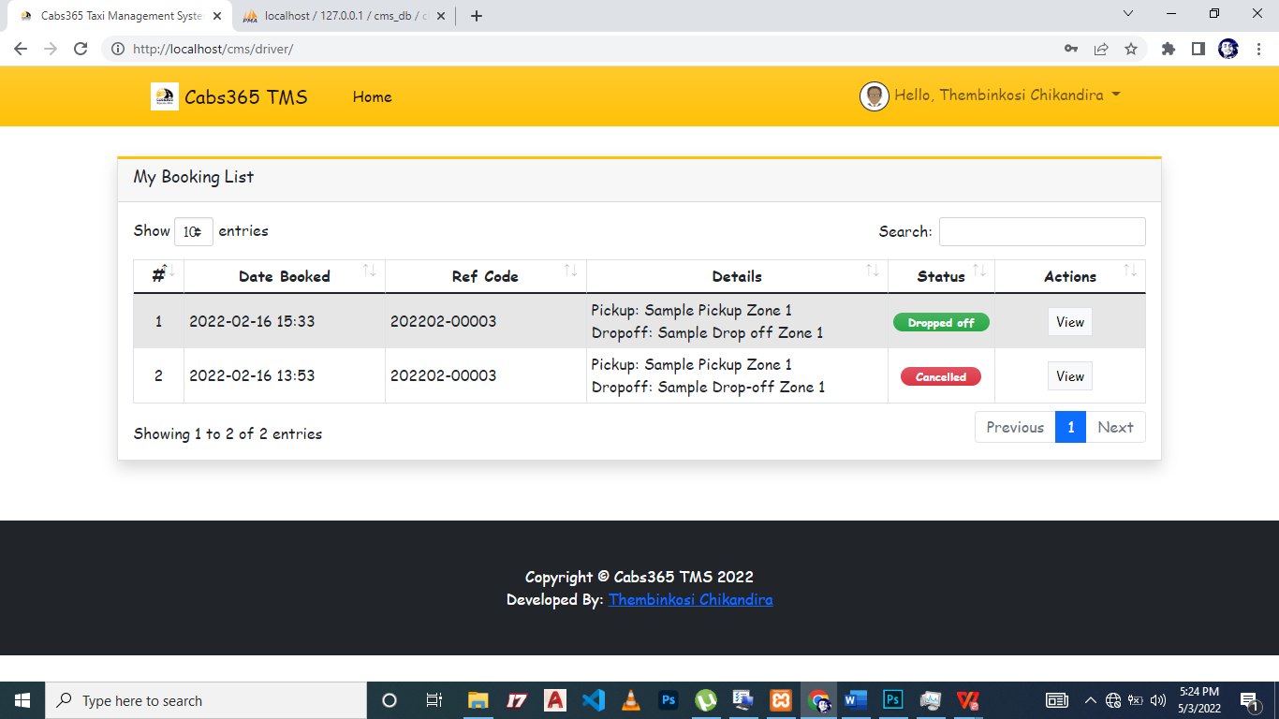

Figure 19: Driver Homepage

### 4.6.6. Driver Views Booking Details

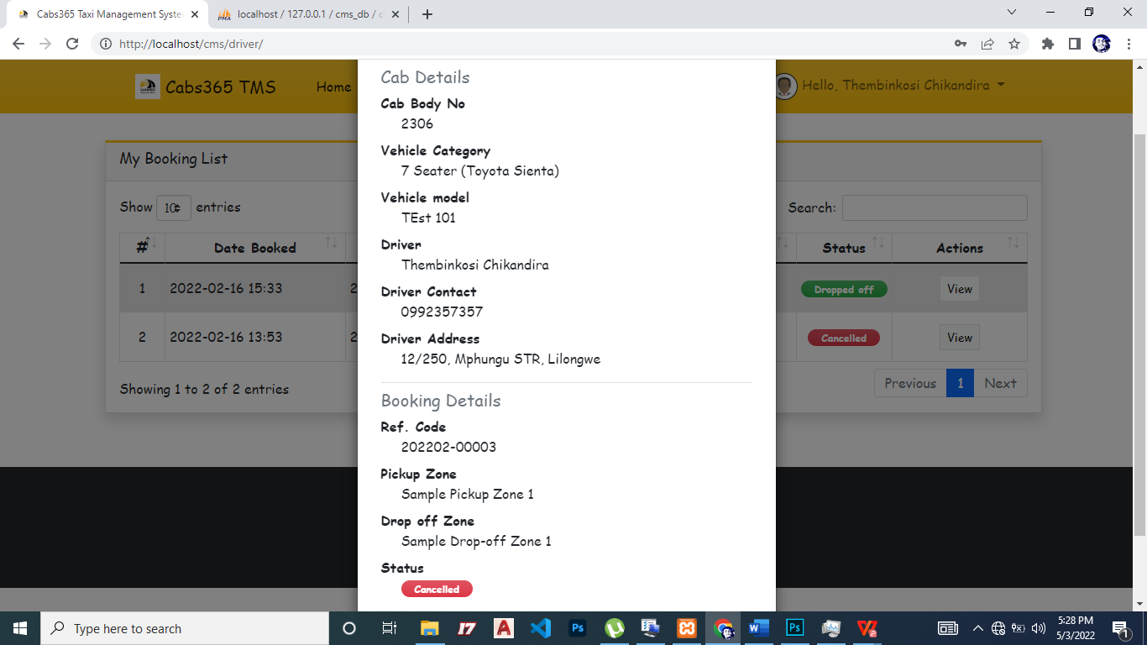

Figure 20: .Driver Views Booking Details

### 4.6.7. Administrator Homepage

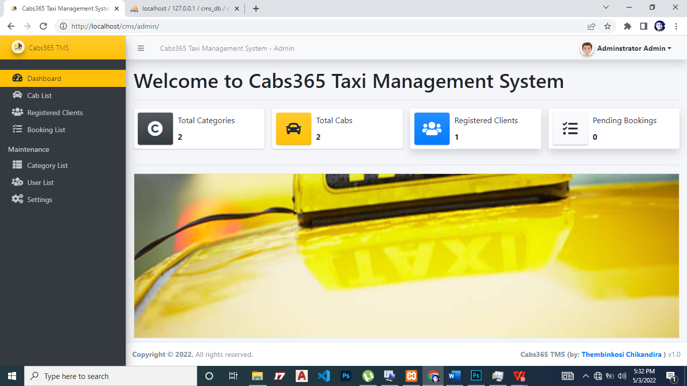

Figure 21: Admin Homepage

### 4.6.8. Administrator Manage Clients

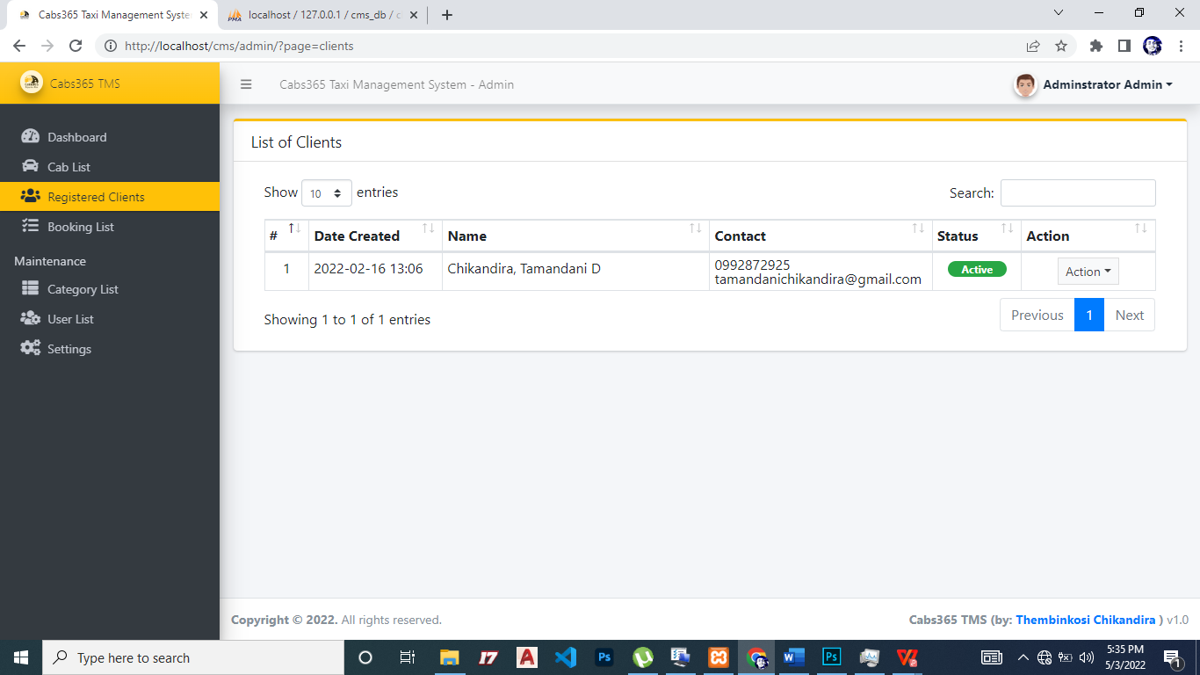

Figure 22: Administrator Manage Clients

### 4.6.9. Administrator Manage Cabs

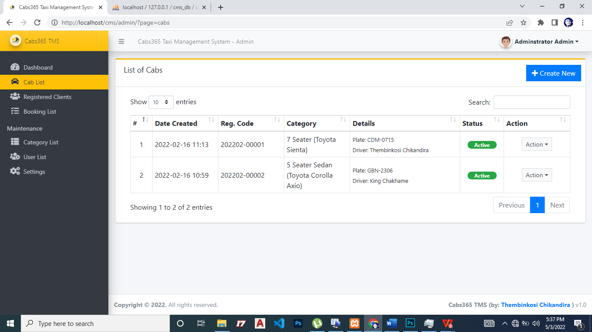

Figure 23: Administrator Manage Cabs

### 4.6.10. Administrator Manage Bookings

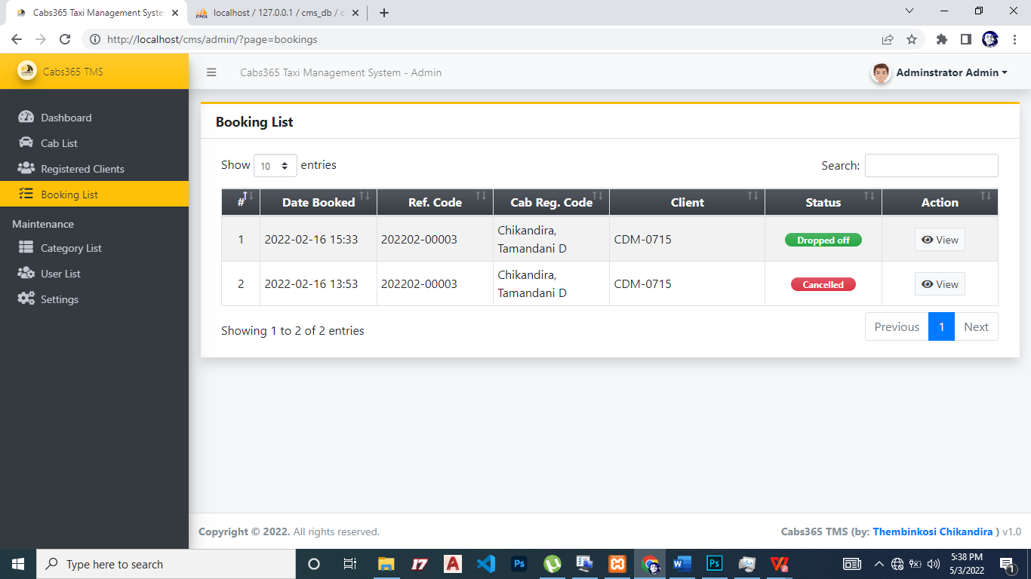

Figure 24: Administrator Manage Bookings

### 4.6.11. Administrator Manage Users

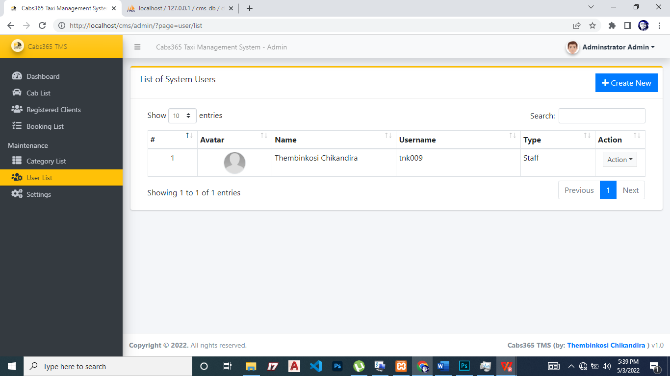

Figure 25: Administrator Manage Users

### 4.6.12. Administrator Manage Website

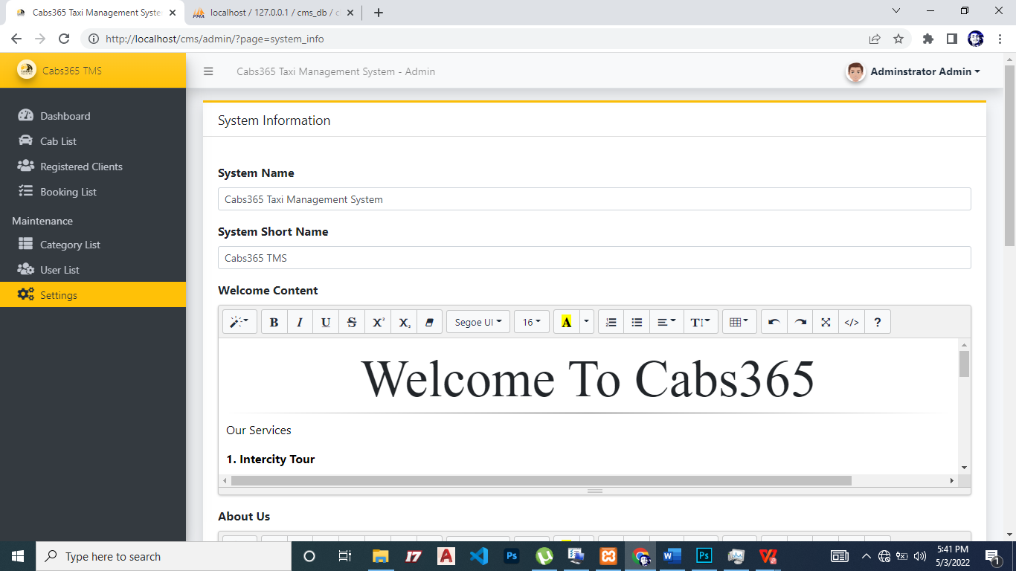

Figure 26: Administrator Manage Website

## 4.7. Objects and Actions

### 4.7.1. Home Screen

On this screen there is login screen and of which it only has one purpose, **Login**. The Login allows the user to submit the details for authentication. There are also two fields namely **Username** and **Password**. The user fills the fields with their username and password. There is also a registration control where a client can register.

### 4.7.2. Client Screen

On this screen the system allows the client to do various tasks like **editing his or her information, make a taxi booking and view their trip/travel logs**.

### 4.7.3. Administrator Screen

This is the first screen that displays once the administrator has successfully login into the system. This screen contains a variety of tasks that an administrator can accomplish with the system. These tasks include **register staff, delete, edit and view report.** Based on what the administrator wants to accomplish, he/she will choose one of these controls in order to achieve the specified task.

### 4.7.4. Driver Screen

On this screen the driver **view client taxi bookings and reports**.

## Quality Assurance

The developed system will be tested by entering expected (valid) and unexpected (invalid) data and then observe the system behavior. When it behaves as intended, the system will be ready for implementation otherwise it will be debugged of the potential errors.

### Detailed test plans

#### Test Plan for Component number 1

**Process name**: Manage user

**Simple case:** Distributor and new user details are typed in on the required fields and click register/add user button.

**Legal input values:** Thembinkosi Chikandira, beneficiary id, location, email, address, phone number.

**Illegal input values**: \ +/,” “, numbers and characters on wrong input fields**.**

**Special case:** The administrator enters staff details into the system for the new users to get registered while the distributor enters details on his or her own.

#### Test plan for component number 2

**Process name:** Authenticate user

**Simple case:** A user enters username and password and clicks login button.

**Legal input values**: chikandira, client, driver, 1234

**Illegal input values**: /, ,‟ „,+ - or numbers on the field for the username.

**Special case:** N/A

#### Test plan for component number 3

**Process name:** Manage cab

**Simple case:** Administrator enters taxi details and clicks on add button

**Legal input values**: cab details

**Illegal input values**: /, ,‟ „,+ -.

**Special case:** calculations are done internally by the system

#### Test plan for component number 4

**Process name:** Manage booking

**Simple case:** Client provides taxi booking details and clicks on save

**Legal input values**: product details

**Illegal input values**: N/A

**Special case:** N/A

#### Test plan for component number 5

**Process name:** Generate report

**Simple case:** The Client, Driver Administrator make report request

**Legal input values**: payment details, distributor details, order details, bonus details, product details type of report

**Illegal input values**: N/A

**Special case:** N/A

# Chapter 4: User Manual

## Installation

Cabs365 TMS requires a Web Server, GSM modem, Mobile Service Provider, Web Browser and a Mobile phone.

Installations folder is included in the Cabs365 TMS package, this folder contains the following applications; XammpServer, and Google Chrome.

### Installation of Google Chrome Browser

Google Chrome is included in the TMS package. To install, open the Google Chrome installer and accept the license agreement terms. Follow the setup wizard steps.

### XammpServer Installation and Configuration

XammpServer is a Windows web development environment. It allows you to create web applications with Apache, PHP and the MySQL database. It also comes with PHPMyAdmin to easily manage your databases. XammpServer installs automatically (installer), and its usage is very intuitive. You will be able to tune your server without even touching the setting files. WampServer

is the only packaged solution that will allow you to reproduce your production server. Once XammpServer is installed, you have the possibility to add as many Apache, MySQL and PHP releases as you want.

##### Installation

Double click on the .exe file and just follow the instructions. Everything is automatic. The XammpServer package is delivered with the latest releases of Apache, MySQL and PHP.

##### Creating the database and importing Tables

Go to phpmyadmin and create a database named ***“cms_db”****.* Import the file ***“cms_db.sql”*** which is in the database folder included in the TMS package. This file will create all required database tables.

##### How to start

When you install WampServer, a "htdocs" directory is created (generally c:\xammp\htdocs). Copy the “cms” to the XamppServer “htdocs” directory. Click on the link "Localhost" in the XamppServer menu or open your browser and open the <http://localhost/cms>. In so doing, the system will automatically open up in your web browser.



Figure 27: Homepage

 <!-- Header-->

 <header class="bg-dark py-5" id="main-header">

    <div class="container h-100 d-flex align-items-center justify-content-center w-100">

        <div class="text-center text-white w-100">

            <h1 class="display-4 fw-bolder mx-5"><?php echo $_settings->info('name') ?></h1>

            <div class="col-auto mt-4">

                <!-- <a class="btn btn-warning btn-lg rounded-0" href="./?p=booking">Book Now</a> -->

            </div>

        </div>

    </div>

</header>

<!-- Section-->

<section class="py-5">

    <div class="container">

        <div class="card shadow card-outline card-warning rounded-0">

            <div class="card-body">

                <?php include './welcome.html' ?>

            </div>

        </div>

    </div>

</section>

<script>

    $(function(){

        $('#search').on('input',function(){

            var _search = $(this).val().toLowerCase().trim()

            $('#service_list .item').each(function(){

                var _text = $(this).text().toLowerCase().trim()

                    _text = _text.replace(/\s+/g,' ')

                    console.log(_text)

                if((_text).includes(_search) == true){

                    $(this).toggle(true)

                }else{

                    $(this).toggle(false)

                }

            })

            if( $('#service_list .item:visible').length > 0){

                $('#noResult').hide('slow')

            }else{

                $('#noResult').show('slow')

            }

        })

        $('#service_list .item').hover(function(){

            $(this).find('.callout').addClass('shadow')

        })

        $('#service_list .view_service').click(function(){

            uni_modal("Service Details","view_service.php?id="+$(this).attr('data-id'),'mid-large')

        })

        $('#send_request').click(function(){

            uni_modal("Fill the Service Request Form","send_request.php",'large')

        })

    })

    $(document).scroll(function() {

        $('#topNavBar').removeClass('bg-transparent navbar-light navbar-dark bg-gradient-warning text-light')

        if($(window).scrollTop() === 0) {

           $('#topNavBar').addClass('navbar-dark bg-transparent text-light')

        }else{

           $('#topNavBar').addClass('navbar-light bg-gradient-warning ')

        }

    });

    $(function(){

        $(document).trigger('scroll')

    })

</script>

#### Using the system

* Start the WampServer
* type http://localhost/cms on your browser



Figure 28: Homepage

* You can now login as administrator (**username:** admin **password**: admin123) and this is the administrator home page
* <?php require_once('../config.php') ?>
* <!DOCTYPE html>
* <html lang="en" class="" style="height: auto;">
* <?php require_once('inc/header.php') ?>
* <body class="hold-transition login-page">
* <script>
* start_loader()
* </script>
* <style>
* body{
* width:calc(100%);
* height:calc(100%);
* background-image:url('<?= validate_image($_settings->info('cover')) ?>');
* background-repeat: no-repeat;
* background-size:cover;
* }
* #logo-img{
* width:15em;
* height:15em;
* object-fit:scale-down;
* object-position:center center;
* }
* </style>
* <div class="login-box">
* <center><img src="<?= validate_image($_settings->info('logo')) ?>" alt="System Logo" class="img-thumbnail rounded-circle" id="logo-img"></center>
* <div class="clear-fix my-2"></div>
* <!-- /.login-logo -->
* <div class="card card-outline card-warning">
* <div class="card-header text-center">
* <a href="./" class="h1"><b>Admin Login</b></a>
* </div>
* <div class="card-body">
* <p class="login-box-msg">Sign in to start your session</p>
* <form id="login-frm" action="" method="post">
* <div class="input-group mb-3">
* <input type="text" class="form-control" name="username" autofocus placeholder="Username">
* <div class="input-group-append">
* <div class="input-group-text">
* <span class="fas fa-user"></span>
* </div>
* </div>
* </div>
* <div class="input-group mb-3">
* <input type="password" class="form-control" name="password" placeholder="Password">
* <div class="input-group-append">
* <div class="input-group-text">
* <span class="fas fa-lock"></span>
* </div>
* </div>
* </div>
* <div class="row">
* <div class="col-8">
* <a href="<?php echo base_url ?>">Back to Site</a>
* </div>
* <!-- /.col -->
* <div class="col-4">
* <button type="submit" class="btn btn-warning btn-flat btn-sm w-100">Sign In</button>
* </div>
* <!-- /.col -->
* </div>
* </form>
* <!-- /.social-auth-links -->
* <!-- <p class="mb-1">
* <a href="forgot-password.html">I forgot my password</a>
* </p> -->
* </div>
* <!-- /.card-body -->
* </div>
* <!-- /.card -->
* </div>
* <!-- /.login-box -->
* <!-- jQuery -->
* <script src="plugins/jquery/jquery.min.js"></script>
* <!-- Bootstrap 4 -->
* <script src="plugins/bootstrap/js/bootstrap.bundle.min.js"></script>
* <!-- AdminLTE App -->
* <script src="dist/js/adminlte.min.js"></script>
* <script>
* $(document).ready(function(){
* end_loader();
* })
* </script>
* </body>
* </html>



Figure 29: Admin Homepage

<?php if($_settings->chk_flashdata('success')): ?>

<script>

    alert_toast("<?php echo $_settings->flashdata('success') ?>",'success')

</script>

<?php endif;?>

<div class="card card-outline card-warning">

    <div class="card-header">

        <h3 class="card-title">List of Cabs</h3>

        <div class="card-tools">

            <a href="?page=cabs/manage_cab" class="btn btn-flat btn-primary"><span class="fas fa-plus"></span>  Create New</a>

        </div>

    </div>

    <div class="card-body">

        <div class="container-fluid">

        <div class="container-fluid">

            <table class="table table-bordered table-stripped">

                <colgroup>

                    <col width="5%">

                    <col width="15%">

                    <col width="15%">

                    <col width="15%">

                    <col width="25%">

                    <col width="10%">

                    <col width="15%">

                </colgroup>

                <thead>

                    <tr>

                        <th>#</th>

                        <th>Date Created</th>

                        <th>Reg. Code</th>

                        <th>Category</th>

                        <th>Details</th>

                        <th>Status</th>

                        <th>Action</th>

                    </tr>

                </thead>

                <tbody>

                    <?php

                    $i = 1;

                        $qry = $conn->query("SELECT c.*,cc.name as category from `cab_list` c inner join category_list cc on c.category_id = cc.id where c.delete_flag = 0 order by (c.`reg_code`) asc ");

                        while($row = $qry->fetch_assoc()):

                            foreach($row as $k=> $v){

                                $row[$k] = trim(stripslashes($v));

                            }

                    ?>

                        <tr>

                            <td class="text-center"><?php echo $i++; ?></td>

                            <td><?php echo date("Y-m-d H:i",strtotime($row['date_created'])) ?></td>

                            <td><?php echo ucwords($row['reg_code']) ?></td>

                            <td><?php echo ucwords($row['category']) ?></td>

                            <td>

                                <div>

                                    <p class="m-0 truncate-1"><small>Plate: <?= $row['cab_reg_no'] ?></small></p>

                                    <p class="m-0 truncate-1"><small>Driver: <?= $row['cab_driver'] ?></small></p>

                                </div>

                            </td>

                            <td class="text-center">

                                <?php if($row['status'] == 1): ?>

                                    <span class="badge badge-success px-3 rounded-pill">Active</span>

                                <?php else: ?>

                                    <span class="badge badge-danger px-3 rounded-pill">Inactive</span>

                                <?php endif; ?>

                            </td>

                            <td align="center">

                                 <button type="button" class="btn btn-flat btn-default btn-sm dropdown-toggle dropdown-icon" data-toggle="dropdown">

                                        Action

                                    <span class="sr-only">Toggle Dropdown</span>

                                  </button>

                                  <div class="dropdown-menu" role="menu">

                                    <a class="dropdown-item" href="?page=cabs/view_cab&id=<?php echo $row['id'] ?>"><span class="fa fa-eye text-dark"></span> View</a>

                                    <div class="dropdown-divider"></div>

                                    <a class="dropdown-item" href="?page=cabs/manage_cab&id=<?php echo $row['id'] ?>"><span class="fa fa-edit text-primary"></span> Edit</a>

                                    <div class="dropdown-divider"></div>

                                    <a class="dropdown-item delete_data" href="javascript:void(0)" data-id="<?php echo $row['id'] ?>"><span class="fa fa-trash text-danger"></span> Delete</a>

                                  </div>

                            </td>

                        </tr>

                    <?php endwhile; ?>

                </tbody>

            </table>

        </div>

        </div>

    </div>

</div>

<script>

    $(document).ready(function(){

        $('.delete_data').click(function(){

            _conf("Are you sure to delete this cab permanently?","delete_cab",[$(this).attr('data-id')])

        })

        $('.table th, .table td').addClass("align-middle px-2 py-1")

        $('.table').dataTable();

        $('.table').dataTable();

    })

    function delete_cab($id){

        start_loader();

        $.ajax({

            url:_base_url_+"classes/Master.php?f=delete_cab",

            method:"POST",

            data:{id: $id},

            dataType:"json",

            error:err=>{

                console.log(err)

                alert_toast("An error occured.",'error');

                end_loader();

            },

            success:function(resp){

                if(typeof resp== 'object' && resp.status == 'success'){

                    location.reload();

                }else{

                    alert_toast("An error occured.",'error');

                    end_loader();

                }

            }

        })

    }

</script>

* You can add a new cab and driver

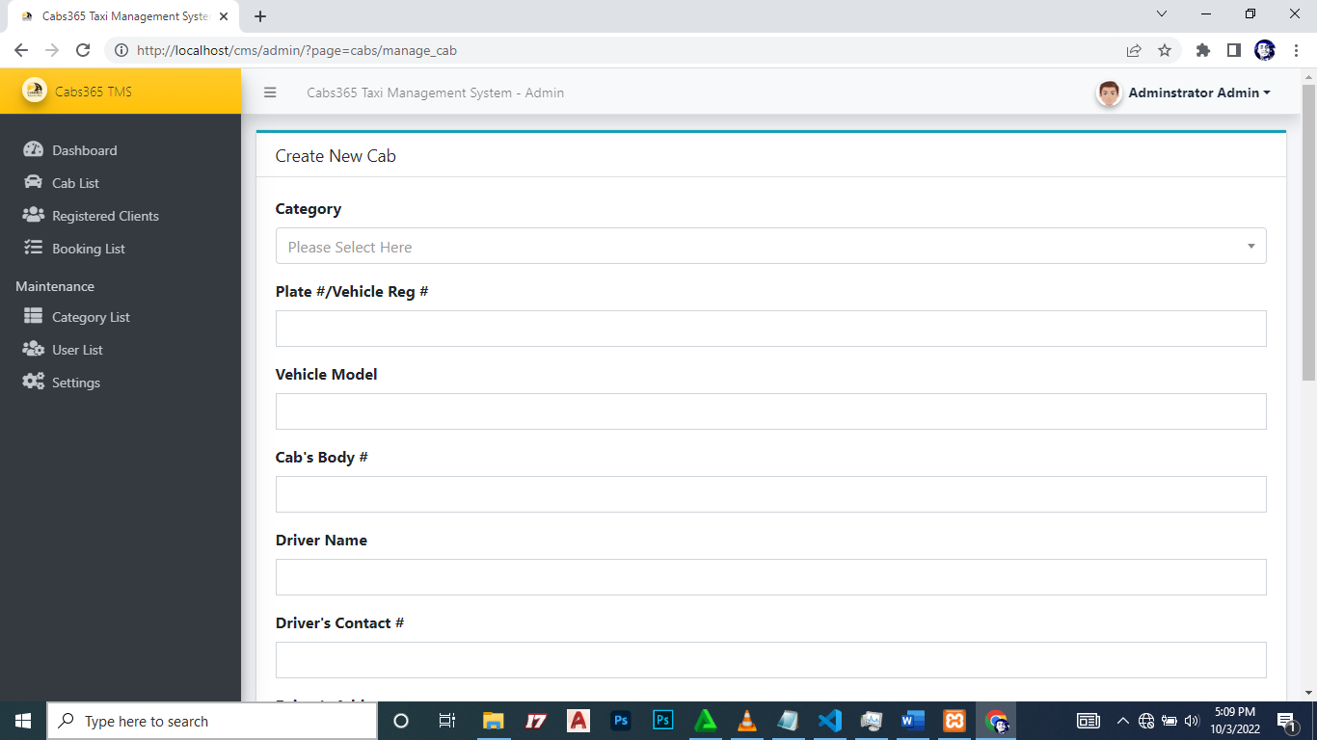

Figure 30: Admin adding new cab

<?php

if(isset($_GET['id']) && $_GET['id'] > 0){

    $qry = $conn->query("SELECT * from `cab_list` where id = '{$_GET['id']}' ");

    if($qry->num_rows > 0){

        foreach($qry->fetch_assoc() as $k => $v){

            $$k=stripslashes($v);

        }

    }

}

?>

<style>

    #cimg{

        width: 15vw;

        height: 20vh;

        object-fit:scale-down;

        object-position:center center;

    }

</style>

<div class="card card-outline card-info rounded-0">

    <div class="card-header">

        <h3 class="card-title"><?php echo isset($id) ? "Update ": "Create New " ?> Cab</h3>

    </div>

    <div class="card-body">

        <form action="" id="cab-form">

            <input type="hidden" name ="id" value="<?php echo isset($id) ? $id : '' ?>">

            <div class="form-group">

                <label for="category_id" class="control-label">Category</label>

                <select name="category_id" id="category_id" class="custom-select select2">

                    <option value="" <?= !isset($category_id) ? "selected" : "" ?> disabled></option>

                    <?php

                    $categorys = $conn->query("SELECT * FROM category_list where delete_flag = 0 ".(isset($category_id) ? " or id = '{$category_id}'" : "")." order by `name` asc ");

                    while($row= $categorys->fetch_assoc()):

                    ?>

                    <option value="<?= $row['id'] ?>" <?= isset($category_id) && $category_id == $row['id'] ? "selected" : "" ?>><?= $row['name'] ?> <?= $row['delete_flag'] == 1 ? "<small>Deleted</small>" : "" ?></option>

                    <?php endwhile; ?>

                </select>

            </div>

            <div class="form-group">

                <label for="cab_reg_no" class="control-label">Plate #/Vehicle Reg #</label>

                <input name="cab_reg_no" id="cab_reg_no" type="text" class="form-control rounded-0" value="<?php echo isset($cab_reg_no) ? $cab_reg_no : ''; ?>" required>

            </div>

            <div class="form-group">

                <label for="cab_model" class="control-label">Vehicle

Model</label>

                <input name="cab_model" id="cab_model" type="text" class="form-control rounded-0" value="<?php echo isset($cab_model) ? $cab_model : ''; ?>" required>

            </div>

            <div class="form-group">

                <label for="body_no" class="control-label">Cab's Body #</label>

                <input name="body_no" id="body_no" type="text" class="form-control rounded-0" value="<?php echo isset($body_no) ? $body_no : ''; ?>" required>

            </div>

            <div class="form-group">

                <label for="cab_driver" class="control-label">Driver Name</label>

                <input name="cab_driver" id="cab_driver" type="text" class="form-control rounded-0" value="<?php echo isset($cab_driver) ? $cab_driver : ''; ?>" required>

            </div>

            <div class="form-group">

                <label for="driver_contact" class="control-label">Driver's Contact #</label>

                <input name="driver_contact" id="driver_contact" type="text" class="form-control rounded-0" value="<?php echo isset($driver_contact) ? $driver_contact : ''; ?>" required>

            </div>

            <div class="form-group">

                <label for="driver_address" class="control-label">Driver's Address</label>

                <textarea name="driver_address" id="driver_address" type="text" class="form-control rounded-0" required><?php echo isset($driver_address) ? $driver_address : ''; ?></textarea>

            </div>

            <div class="form-group">

                <label for="password" class="control-label">Driver's Account Password</label>

                <div class="input-group">

                    <input name="password" id="password" type="password" class="form-control rounded-0" <?php echo !isset($password) ? 'required' : ''; ?>>

                    <div class="input-group-append">

                        <button class="btn btn-outline-default pass_view" type="button"><i class="fa fa-eye-slash"></i></button>

                    </div>

                </div>

                <small class="text-muted"><i>Leave this field blank if you don't wish to update the driver's account password.</i></small>

            </div>

            <div class="form-group col-md-6">

                <label for="" class="control-label">Driver's Image</label>

                <div class="custom-file">

                  <input type="file" class="custom-file-input rounded-circle" id="customFile" name="img" onchange="displayImg(this,$(this))">

                  <label class="custom-file-label" for="customFile">Choose file</label>

                </div>

            </div>

            <div class="form-group col-md-6 d-flex justify-content-center">

                <img src="<?php echo validate_image(isset($image_path) ? $image_path : "") ?>" alt="" id="cimg" class="img-fluid img-thumbnail bg-gradient-gray">

            </div>

            <div class="form-group">

                <label for="status" class="control-label">Status</label>

                <select name="status" id="status" class="custom-select selevt">

                <option value="1" <?php echo isset($status) && $status == 1 ? 'selected' : '' ?>>Active</option>

                <option value="0" <?php echo isset($status) && $status == 0 ? 'selected' : '' ?>>Inactive</option>

                </select>

            </div>

        </form>

    </div>

    <div class="card-footer">

        <button class="btn btn-flat btn-primary" form="cab-form">Save</button>

        <a class="btn btn-flat btn-default" href="?page=cabs">Cancel</a>

    </div>

</div>

<script>

    window.displayImg = function(input,_this) {

        if (input.files && input.files[0]) {

            var reader = new FileReader();

            reader.onload = function (e) {

                $('#cimg').attr('src', e.target.result);

                _this.siblings('.custom-file-label').html(input.files[0].name)

            }

            reader.readAsDataURL(input.files[0]);

        }else{

            $('#cimg').attr('src', "<?php echo validate_image(isset($image_path) ? $image_path : "") ?>");

            _this.siblings('.custom-file-label').html("Choose file")

        }

    }

    $(document).ready(function(){

        $('.select2').select2({

            width:'100%',

            placeholder:"Please Select Here"

        })

        $('.pass_view').click(function(){

            var group = $(this).closest('.input-group');

            var type = group.find('input').attr('type')

            if(type == 'password'){

                group.find('input').attr('type','text').focus()

                $(this).html('<i class="fa fa-eye"></i>')

            }else{

                group.find('input').attr('type','password').focus()

                $(this).html('<i class="fa fa-eye-slash"></i>')

            }

        })

        $('#cab-form').submit(function(e){

            e.preventDefault();

            var _this = $(this)

             $('.err-msg').remove();

            start_loader();

            $.ajax({

                url:_base_url_+"classes/Master.php?f=save_cab",

                data: new FormData($(this)[0]),

                cache: false,

                contentType: false,

                processData: false,

                method: 'POST',

                type: 'POST',

                dataType: 'json',

                error:err=>{

                    console.log(err)

                    alert_toast("An error occured",'error');

                    end_loader();

                },

                success:function(resp){

                    if(typeof resp =='object' && resp.status == 'success'){

                        location.href = "./?page=cabs/view_cab&id="+resp.id;

                    }else if(resp.status == 'failed' && !!resp.msg){

                        var el = $('<div>')

                            el.addClass("alert alert-danger err-msg").text(resp.msg)

                            _this.prepend(el)

                            el.show('slow')

                            $("html, body").animate({ scrollTop: _this.closest('.card').offset().top }, "fast");

                            end_loader()

                    }else{

                        alert_toast("An error occured",'error');

                        end_loader();

                        console.log(resp)

                    }

                }

            })

        })

        $('.summernote').summernote({

                height: 200,

                toolbar: [

                    [ 'style', [ 'style' ] ],

                    [ 'font', [ 'bold', 'italic', 'underline', 'strikethrough', 'superscript', 'subscript', 'clear'] ],

                    [ 'fontname', [ 'fontname' ] ],

                    [ 'fontsize', [ 'fontsize' ] ],

                    [ 'color', [ 'color' ] ],

                    [ 'para', [ 'ol', 'ul', 'paragraph', 'height' ] ],

                    [ 'table', [ 'table' ] ],

                    [ 'view', [ 'undo', 'redo', 'fullscreen', 'codeview', 'help' ] ]

                ]

            })

    })

</script>

* System information can be updated from the admin panel.

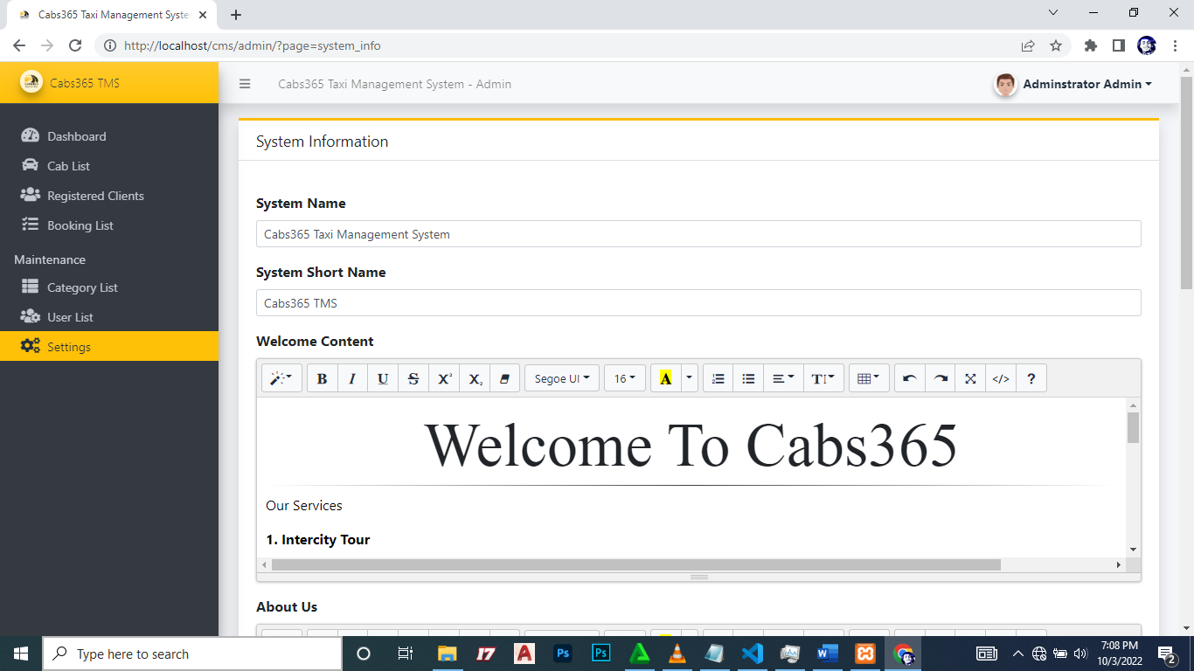

Figure 31: Admin editing system information

<?php if($_settings->chk_flashdata('success')): ?>

<script>

    alert_toast("<?php echo $_settings->flashdata('success') ?>",'success')

</script>

<?php endif;?>

<style>

    img#cimg{

        height: 15vh;

        width: 15vh;

        object-fit: cover;

        border-radius: 100% 100%;

    }

    img#cimg2{

        height: 50vh;

        width: 100%;

        object-fit: contain;

        /* border-radius: 100% 100%; */

    }

</style>

<div class="col-lg-12">

    <div class="card card-outline card-warning rounded-0 shadow">

        <div class="card-header">

            <h5 class="card-title">System Information</h5>

            <!-- <div class="card-tools">

                <a class="btn btn-block btn-sm btn-default btn-flat border-primary new_department" href="javascript:void(0)"><i class="fa fa-plus"></i> Add New</a>

            </div> -->

        </div>

        <div class="card-body">

            <form action="" id="system-frm">

            <div id="msg" class="form-group"></div>

            <div class="form-group">

                <label for="name" class="control-label">System Name</label>

                <input type="text" class="form-control form-control-sm" name="name" id="name" value="<?php echo $_settings->info('name') ?>">

            </div>

            <div class="form-group">

                <label for="short_name" class="control-label">System Short Name</label>

                <input type="text" class="form-control form-control-sm" name="short_name" id="short_name" value="<?php echo  $_settings->info('short_name') ?>">

            </div>

            <div class="form-group">

                <label for="" class="control-label">Welcome Content</label>

                 <textarea name="content[welcome]" id="" cols="30" rows="2" class="form-control summernote"><?php echo  is_file(base_app.'welcome.html') ? file_get_contents(base_app.'welcome.html') : "" ?></textarea>

            </div>

            <div class="form-group">

                <label for="" class="control-label">About Us</label>

                 <textarea name="content[about]" id="" cols="30" rows="2" class="form-control summernote"><?php echo  is_file(base_app.'about.html') ? file_get_contents(base_app.'about.html') : "" ?></textarea>

            </div>

            <div class="form-group">

                <label for="" class="control-label">System Logo</label>

                <div class="custom-file">

                  <input type="file" class="custom-file-input rounded-circle" id="customFile" name="img" onchange="displayImg(this,$(this))">

                  <label class="custom-file-label" for="customFile">Choose file</label>

                </div>

            </div>

            <div class="form-group d-flex justify-content-center">

                <img src="<?php echo validate_image($_settings->info('logo')) ?>" alt="" id="cimg" class="img-fluid img-thumbnail">

            </div>

            <div class="form-group">

                <label for="" class="control-label">Website Cover</label>

                <div class="custom-file">

                  <input type="file" class="custom-file-input rounded-circle" id="customFile" name="cover" onchange="displayImg2(this,$(this))">

                  <label class="custom-file-label" for="customFile">Choose file</label>

                </div>

            </div>

            <div class="form-group d-flex justify-content-center">

                <img src="<?php echo validate_image($_settings->info('cover')) ?>" alt="" id="cimg2" class="img-fluid img-thumbnail">

            </div>

            </form>

        </div>

        <div class="card-footer">

            <div class="col-md-12">

                <div class="row">

                    <button class="btn btn-sm btn-primary" form="system-frm">Update</button>

                </div>

            </div>

        </div>

    </div>

</div>

<script>

    function displayImg(input,_this) {

        if (input.files && input.files[0]) {

            var reader = new FileReader();

            reader.onload = function (e) {

                $('#cimg').attr('src', e.target.result);

                _this.siblings('.custom-file-label').html(input.files[0].name)

            }

            reader.readAsDataURL(input.files[0]);

        }

    }

    function displayImg2(input,_this) {

        if (input.files && input.files[0]) {

            var reader = new FileReader();

            reader.onload = function (e) {

                _this.siblings('.custom-file-label').html(input.files[0].name)

                $('#cimg2').attr('src', e.target.result);

            }

            reader.readAsDataURL(input.files[0]);

        }

    }

    function displayImg3(input,_this) {

        if (input.files && input.files[0]) {

            var reader = new FileReader();

            reader.onload = function (e) {

                _this.siblings('.custom-file-label').html(input.files[0].name)

                $('#cimg3').attr('src', e.target.result);

            }

            reader.readAsDataURL(input.files[0]);

        }

    }

    $(document).ready(function(){

         $('.summernote').summernote({

                height: 200,

                toolbar: [

                    [ 'style', [ 'style' ] ],

                    [ 'font', [ 'bold', 'italic', 'underline', 'strikethrough', 'superscript', 'subscript', 'clear'] ],

                    [ 'fontname', [ 'fontname' ] ],

                    [ 'fontsize', [ 'fontsize' ] ],

                    [ 'color', [ 'color' ] ],

                    [ 'para', [ 'ol', 'ul', 'paragraph', 'height' ] ],

                    [ 'table', [ 'table' ] ],

                    [ 'view', [ 'undo', 'redo', 'fullscreen', 'codeview', 'help' ] ]

                ]

            })

    })

</script>

* Admin can view details of all bookings and can also generate a report.

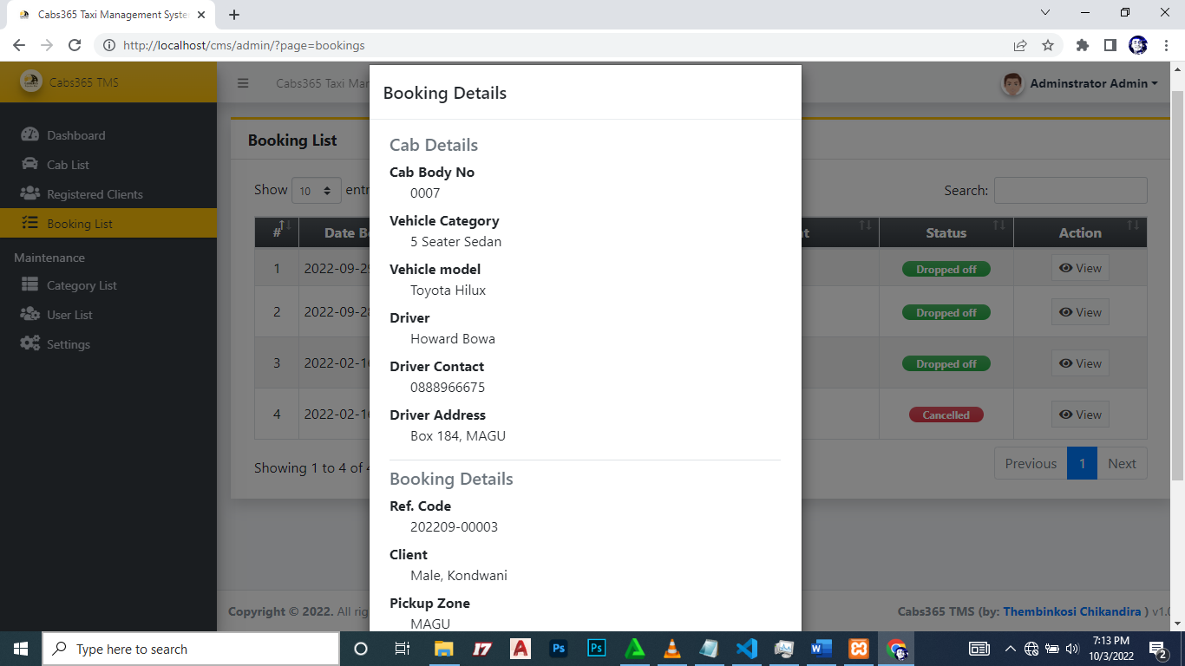

Figure 32: View Booking details

<div class="card card-outline card-warning shadow rounded-0">

    <div class="card-header">

        <h3 class="card-title"><b>Booking List</b></h3>

    </div>

    <div class="card-body">

        <div class="container-fluid">

            <table class="table table-striped table-bordered">

                <colgroup>

                    <col width="5%">

                    <col width="15%">

                    <col width="15%">

                    <col width="15%">

                    <col width="20%">

                    <col width="15%">

                    <col width="15%">

                </colgroup>

                <thead>

                    <tr class="bg-gradient-dark text-light">

                        <th class="text-center">#</th>

                        <th class="text-center">Date Booked</th>

                        <th class="text-center">Ref. Code</th>

                        <th class="text-center">Cab Reg. Code</th>

                        <th class="text-center">Client</th>

                        <th class="text-center">Status</th>

                        <th class="text-center">Action</th>

                    </tr>

                </thead>

                <tbody>

                    <?php

                    $i = 1;

                    $bookings = $conn->query("SELECT b.*,concat(c.lastname,', ', c.firstname,' ',c.middlename) as client, cab_reg_no FROM `booking_list` b inner join client_list c on b.client_id = c.id inner join cab_list cc on b.cab_id = cc.id order by unix_timestamp(b.date_created) desc ");

                    while($row = $bookings->fetch_assoc()):

                    ?>

                        <tr>

                            <td class="text-center"><?= $i++ ?></td>

                            <td><?= date("Y-m-d H:i", strtotime($row['date_created'])) ?></td>

                            <td><?= $row['ref_code'] ?></td>

                            <td><?= $row['client'] ?></td>

                            <td><?= $row['cab_reg_no'] ?></td>

                            <td class="text-center">

                                <?php

                                    switch($row['status']){

                                        case 0:

                                            echo "<span class='badge badge-secondary bg-gradient-secondary px-3 rounded-pill'>Pending</span>";

                                            break;

                                        case 1:

                                            echo "<span class='badge badge-primary bg-gradient-primary px-3 rounded-pill'>Driver Confirmed</span>";

                                            break;

                                        case 2:

                                            echo "<span class='badge badge-warning bg-gradient-warning px-3 rounded-pill'>Picked-up</span>";

                                            break;

                                        case 3:

                                            echo "<span class='badge badge-success bg-gradient-success px-3 rounded-pill'>Dropped off</span>";

                                            break;

                                        case 4:

                                            echo "<span class='badge badge-danger bg-gradient-danger px-3 rounded-pill'>Cancelled</span>";

                                            break;

                                    }

                                ?>

                            </td>

                            </td>

                            <td class="text-center">

                                <a class="btn btn-flat btn-sm btn-default border view_data" href="javascript:void(0)" data-id="<?= $row['id'] ?>"><i class="fa fa-eye"></i> View</a>

                            </td>

                        </tr>

                    <?php endwhile; ?>

                </tbody>

            </table>

        </div>

    </div>

</div>

<script>

    $(function(){

        $('.table th, .table td').addClass("align-middle px-2 py-1")

        $('.table').dataTable();

        $('.table').dataTable();

        $('.view_data').click(function(){

            uni_modal("Booking Details","bookings/view_booking.php?id="+$(this).attr('data-id'))

        })

    })

</script>

<?php

require_once('./../../config.php');

if(isset($_GET['id']) && $_GET['id'] > 0){

    $qry = $conn->query("SELECT  b.*,concat(c.lastname,', ', c.firstname,' ',c.middlename) as client from `booking_list` b inner join client_list c on b.client_id = c.id where b.id = '{$_GET['id']}' ");

    if($qry->num_rows > 0){

        foreach($qry->fetch_assoc() as $k => $v){

            $$k=$v;

        }

        $qry2 = $conn->query("SELECT c.*, cc.name as category from `cab_list` c inner join category_list cc on c.category_id = cc.id where c.id = '{$cab_id}' ");

        if($qry2->num_rows > 0){

            foreach($qry2->fetch_assoc() as $k => $v){

                if(!isset($$k))

                $$k=$v;

            }

        }

    }

}

?>

<style>

    #uni_modal .modal-footer{

        display:none

    }

</style>

<div class="container-fluid">

    <fieldset class="border-bottom">

        <legend class="h5 text-muted"> Cab Details</legend>

        <dl>

            <dt class="">Cab Body No</dt>

            <dd class="pl-4"><?= isset($body_no) ? $body_no : "" ?></dd>

            <dt class="">Vehicle Category</dt>

            <dd class="pl-4"><?= isset($category) ? $category : "" ?></dd>

            <dt class="">Vehicle model</dt>

            <dd class="pl-4"><?= isset($cab_model) ? $cab_model : "" ?></dd>

            <dt class="">Driver</dt>

            <dd class="pl-4"><?= isset($cab_driver) ? $cab_driver : "" ?></dd>

            <dt class="">Driver Contact</dt>

            <dd class="pl-4"><?= isset($driver_contact) ? $driver_contact : "" ?></dd>

            <dt class="">Driver Address</dt>

            <dd class="pl-4"><?= isset($driver_address) ? $driver_address : "" ?></dd>

        </dl>

    </fieldset>

    <div class="clear-fix my-2"></div>

    <fieldset class="bor">

        <legend class="h5 text-muted"> Booking Details</legend>

        <dl>

            <dt class="">Ref. Code</dt>

            <dd class="pl-4"><?= isset($ref_code) ? $ref_code : "" ?></dd>

            <dt class="">Client</dt>

            <dd class="pl-4"><?= isset($client) ? $client : "" ?></dd>

            <dt class="">Pickup Zone</dt>

            <dd class="pl-4"><?= isset($pickup_zone) ? $pickup_zone : "" ?></dd>

            <dt class="">Drop off Zone</dt>

            <dd class="pl-4"><?= isset($drop_zone) ? $drop_zone : "" ?></dd>

            <dt class="">Status</dt>

            <dd class="pl-4">

                <?php

                    switch($status){

                        case 0:

                            echo "<span class='badge badge-secondary bg-gradient-secondary px-3 rounded-pill'>Pending</span>";

                            break;

                        case 1:

                            echo "<span class='badge badge-primary bg-gradient-primary px-3 rounded-pill'>Driver Confirmed</span>";

                            break;

                        case 2:

                            echo "<span class='badge badge-warning bg-gradient-warning px-3 rounded-pill'>Picked-up</span>";

                            break;

                        case 3:

                            echo "<span class='badge badge-success bg-gradient-success px-3 rounded-pill'>Dropped off</span>";

                            break;

                        case 4:

                            echo "<span class='badge badge-danger bg-gradient-danger px-3 rounded-pill'>Cancelled</span>";

                            break;

                    }

                ?>

            </dd>

        </dl>

    </fieldset>

    <div class="clear-fix my-3"></div>

    <div class="text-right">

        <button class="btn btn-dark btn-flat bg-gradient-dark" type="button" data-dismiss="modal"><i class="fa fa-times"></i> Close</button>

    </div>

</div>

* You can login as a driver (**code:** 202202-00001 **password**: 12345) and this is the driver home page
* <?php require_once('./../config.php') ?>
* <!DOCTYPE html>
* <html lang="en" class="" style="height: auto;">
* <?php require_once('inc/header.php') ?>
* <body class="hold-transition login-page">
* <script>
* start_loader()
* </script>
* <style>
* body{
* width:calc(100%);
* height:calc(100%);
* background-image:url('<?= validate_image($_settings->info('cover')) ?>');
* background-repeat: no-repeat;
* background-size:cover;
* }
* #logo-img{
* width:15em;
* height:15em;
* object-fit:scale-down;
* object-position:center center;
* }
* </style>
* <div class="login-box">
* <?php $page = isset($_GET['page']) ? $_GET['page'] : 'home';  ?>
* <?php if($_settings->chk_flashdata('success')): ?>
* <script>
* alert_toast("<?php echo $_settings->flashdata('success') ?>",'success')
* </script>
* <?php endif;?>
* <!-- /.login-logo -->
* <center><img src="<?= validate_image($_settings->info('logo')) ?>" alt="System Logo" class="img-thumbnail rounded-circle" id="logo-img"></center>
* <div class="clear-fix my-2"></div>
* <div class="card card-outline card-warning">
* <div class="card-header text-center">
* <a href="./" class="h1 text-decoration-none"><b>Login</b></a>
* </div>
* <div class="card-body">
* <p class="login-box-msg">Sign in to start your session</p>
* <form id="dlogin-frm" action="" method="post">
* <div class="input-group mb-3">
* <input type="text" class="form-control" name="reg_code" autofocus placeholder="Code">
* <div class="input-group-append">
* <div class="input-group-text">
* <span class="fas fa-user"></span>
* </div>
* </div>
* </div>
* <div class="input-group mb-3">
* <input type="password" class="form-control" name="password" placeholder="Password">
* <div class="input-group-append">
* <div class="input-group-text">
* <span class="fas fa-lock"></span>
* </div>
* </div>
* </div>
* <div class="row align-items-center">
* <div class="col-8">
* <a href="<?php echo base_url ?>">Back to Site</a>
* </div>
* <!-- /.col -->
* <div class="col-4">
* <button type="submit" class="btn btn-warning btn-sm btn-flat btn-block">Sign In</button>
* </div>
* <!-- /.col -->
* </div>
* </form>
* <!-- /.social-auth-links -->
* <!-- <p class="mb-1">
* <a href="forgot-password.html">I forgot my password</a>
* </p> -->
* </div>
* <!-- /.card-body -->
* </div>
* <!-- /.card -->
* </div>
* <!-- /.login-box -->
* <!-- jQuery -->
* <script src="plugins/jquery/jquery.min.js"></script>
* <!-- Bootstrap 4 -->
* <script src="plugins/bootstrap/js/bootstrap.bundle.min.js"></script>
* <!-- AdminLTE App -->
* <script src="dist/js/adminlte.min.js"></script>
* <script>
* $(document).ready(function(){
* end_loader();
* })
* </script>
* </body>
* </html>
* <?php require_once('./../config.php') ?>
* <!DOCTYPE html>
* <html lang="en" class="" style="height: auto;">
* <?php require_once('inc/header.php') ?>
* <body class="hold-transition login-page">
* <script>
* start_loader()
* </script>
* <style>
* body{
* width:calc(100%);
* height:calc(100%);
* background-image:url('<?= validate_image($_settings->info('cover')) ?>');
* background-repeat: no-repeat;
* background-size:cover;
* }
* #logo-img{
* width:15em;
* height:15em;
* object-fit:scale-down;
* object-position:center center;
* }
* </style>
* <div class="login-box">
* <?php $page = isset($_GET['page']) ? $_GET['page'] : 'home';  ?>
* <?php if($_settings->chk_flashdata('success')): ?>
* <script>
* alert_toast("<?php echo $_settings->flashdata('success') ?>",'success')
* </script>
* <?php endif;?>
* <!-- /.login-logo -->
* <center><img src="<?= validate_image($_settings->info('logo')) ?>" alt="System Logo" class="img-thumbnail rounded-circle" id="logo-img"></center>
* <div class="clear-fix my-2"></div>
* <div class="card card-outline card-warning">
* <div class="card-header text-center">
* <a href="./" class="h1 text-decoration-none"><b>Login</b></a>
* </div>
* <div class="card-body">
* <p class="login-box-msg">Sign in to start your session</p>
* <form id="dlogin-frm" action="" method="post">
* <div class="input-group mb-3">
* <input type="text" class="form-control" name="reg_code" autofocus placeholder="Code">
* <div class="input-group-append">
* <div class="input-group-text">
* <span class="fas fa-user"></span>
* </div>
* </div>
* </div>
* <div class="input-group mb-3">
* <input type="password" class="form-control" name="password" placeholder="Password">
* <div class="input-group-append">
* <div class="input-group-text">
* <span class="fas fa-lock"></span>
* </div>
* </div>
* </div>
* <div class="row align-items-center">
* <div class="col-8">
* <a href="<?php echo base_url ?>">Back to Site</a>
* </div>
* <!-- /.col -->
* <div class="col-4">
* <button type="submit" class="btn btn-warning btn-sm btn-flat btn-block">Sign In</button>
* </div>
* <!-- /.col -->
* </div>
* </form>
* <!-- /.social-auth-links -->
* <!-- <p class="mb-1">
* <a href="forgot-password.html">I forgot my password</a>
* </p> -->
* </div>
* <!-- /.card-body -->
* </div>
* <!-- /.card -->
* </div>
* <!-- /.login-box -->
* <!-- jQuery -->
* <script src="plugins/jquery/jquery.min.js"></script>
* <!-- Bootstrap 4 -->
* <script src="plugins/bootstrap/js/bootstrap.bundle.min.js"></script>
* <!-- AdminLTE App -->
* <script src="dist/js/adminlte.min.js"></script>
* <script>
* $(document).ready(function(){
* end_loader();
* })
* </script>
* </body>
* </html>



Figure 33: View Booking Details

<?php require_once('./../config.php') ?>

<!DOCTYPE html>

<html lang="en" class="" style="height: auto;">

 <?php require_once('inc/header.php') ?>

<body class="hold-transition login-page">

  <script>

    start_loader()

  </script>

  <style>

      body{

          width:calc(100%);

          height:calc(100%);

          background-image:url('<?= validate_image($_settings->info('cover')) ?>');

          background-repeat: no-repeat;

          background-size:cover;

      }

      #logo-img{

          width:15em;

          height:15em;

          object-fit:scale-down;

          object-position:center center;

      }

  </style>

<div class="login-box">

<?php $page = isset($_GET['page']) ? $_GET['page'] : 'home';  ?>

     <?php if($_settings->chk_flashdata('success')): ?>

      <script>

        alert_toast("<?php echo $_settings->flashdata('success') ?>",'success')

      </script>

    <?php endif;?>

  <!-- /.login-logo -->

  <center><img src="<?= validate_image($_settings->info('logo')) ?>" alt="System Logo" class="img-thumbnail rounded-circle" id="logo-img"></center>

  <div class="clear-fix my-2"></div>

  <div class="card card-outline card-warning">

    <div class="card-header text-center">

      <a href="./" class="h1 text-decoration-none"><b>Login</b></a>

    </div>

    <div class="card-body">

      <p class="login-box-msg">Sign in to start your session</p>

      <form id="dlogin-frm" action="" method="post">

        <div class="input-group mb-3">

          <input type="text" class="form-control" name="reg_code" autofocus placeholder="Code">

          <div class="input-group-append">

            <div class="input-group-text">

              <span class="fas fa-user"></span>

            </div>

          </div>

        </div>

        <div class="input-group mb-3">

          <input type="password" class="form-control" name="password" placeholder="Password">

          <div class="input-group-append">

            <div class="input-group-text">

              <span class="fas fa-lock"></span>

            </div>

          </div>

        </div>

        <div class="row align-items-center">

          <div class="col-8">

            <a href="<?php echo base_url ?>">Back to Site</a>

          </div>

          <!-- /.col -->

          <div class="col-4">

            <button type="submit" class="btn btn-warning btn-sm btn-flat btn-block">Sign In</button>

          </div>

          <!-- /.col -->

        </div>

      </form>

      <!-- /.social-auth-links -->

      <!-- <p class="mb-1">

        <a href="forgot-password.html">I forgot my password</a>

      </p> -->

    </div>

    <!-- /.card-body -->

  </div>

  <!-- /.card -->

</div>

<!-- /.login-box -->

<!-- jQuery -->

<script src="plugins/jquery/jquery.min.js"></script>

<!-- Bootstrap 4 -->

<script src="plugins/bootstrap/js/bootstrap.bundle.min.js"></script>

<!-- AdminLTE App -->

<script src="dist/js/adminlte.min.js"></script>

<script>

  $(document).ready(function(){

    end_loader();

  })

</script>

</body>

</html>

* Admin account can be managed.

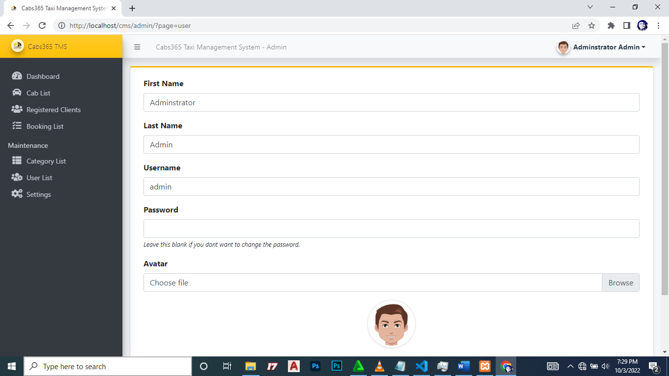

Figure 34: Admin Account Management

<?php

if(isset($_GET['id']) && $_GET['id'] > 0){

    $user = $conn->query("SELECT * FROM users where id ='{$_GET['id']}'");

    foreach($user->fetch_array() as $k =>$v){

        $meta[$k] = $v;

    }

}

?>

<?php if($_settings->chk_flashdata('success')): ?>

<script>

    alert_toast("<?php echo $_settings->flashdata('success') ?>",'success')

</script>

<?php endif;?>

<div class="card card-outline card-warning">

    <div class="card-body">

        <div class="container-fluid">

            <div id="msg"></div>

            <form action="" id="manage-user">

                <input type="hidden" name="id" value="<?php echo isset($meta['id']) ? $meta['id']: '' ?>">

                <div class="form-group col-6">

                    <label for="name">First Name</label>

                    <input type="text" name="firstname" id="firstname" class="form-control" value="<?php echo isset($meta['firstname']) ? $meta['firstname']: '' ?>" required>

                </div>

                <div class="form-group col-6">

                    <label for="name">Last Name</label>

                    <input type="text" name="lastname" id="lastname" class="form-control" value="<?php echo isset($meta['lastname']) ? $meta['lastname']: '' ?>" required>

                </div>

                <div class="form-group col-6">

                    <label for="username">Username</label>

                    <input type="text" name="username" id="username" class="form-control" value="<?php echo isset($meta['username']) ? $meta['username']: '' ?>" required  autocomplete="off">

                </div>

                <div class="form-group col-6">

                    <label for="password">Password</label>

                    <input type="password" name="password" id="password" class="form-control" value="" autocomplete="off" <?php echo isset($meta['id']) ? "": 'required' ?>>

                    <?php if(isset($_GET['id'])): ?>

                    <small><i>Leave this blank if you dont want to change the password.</i></small>

                    <?php endif; ?>

                </div>

                <div class="form-group col-6">

                    <label for="type">Login Type</label>

                    <select name="type" id="type" class="custom-select">

                        <option value="1" <?php echo isset($meta['type']) && $meta['type'] == 1 ? 'selected' : '' ?>>Administrator</option>

                        <option value="2" <?php echo isset($meta['type']) && $meta['type'] == 2 ? 'selected' : '' ?>>Staff</option>

                    </select>

                </div>

                <div class="form-group col-6">

                    <label for="" class="control-label">Avatar</label>

                    <div class="custom-file">

                      <input type="file" class="custom-file-input rounded-circle" id="customFile" name="img" onchange="displayImg(this,$(this))">

                      <label class="custom-file-label" for="customFile">Choose file</label>

                    </div>

                </div>

                <div class="form-group col-6 d-flex justify-content-center">

                    <img src="<?php echo validate_image(isset($meta['avatar']) ? $meta['avatar'] :'') ?>" alt="" id="cimg" class="img-fluid img-thumbnail">

                </div>

            </form>

        </div>

    </div>

    <div class="card-footer">

            <div class="col-md-12">

                <div class="row">

                    <button class="btn btn-sm btn-primary mr-2" form="manage-user">Save</button>

                    <a class="btn btn-sm btn-secondary" href="./?page=user/list">Cancel</a>

                </div>

            </div>

        </div>

</div>

<style>

    img#cimg{

        height: 15vh;

        width: 15vh;

        object-fit: cover;

        border-radius: 100% 100%;

    }

</style>

<script>

    function displayImg(input,_this) {

        if (input.files && input.files[0]) {

            var reader = new FileReader();

            reader.onload = function (e) {

                $('#cimg').attr('src', e.target.result);

            }

            reader.readAsDataURL(input.files[0]);

        }

    }

    $('#manage-user').submit(function(e){

        e.preventDefault();

var _this = $(this)

        start_loader()

        $.ajax({

            url:_base_url_+'classes/Users.php?f=save',

            data: new FormData($(this)[0]),

            cache: false,

            contentType: false,

            processData: false,

            method: 'POST',

            type: 'POST',

            success:function(resp){

                if(resp ==1){

                    location.href = './?page=user/list';

                }else{

                    $('#msg').html('<div class="alert alert-danger">Username already exist</div>')

                    $("html, body").animate({ scrollTop: 0 }, "fast");

                }

                end_loader()

            }

        })

    })

</script>

* You can login as a client (**code:** 202202-00001 **password**: 12345) and this is the client home page

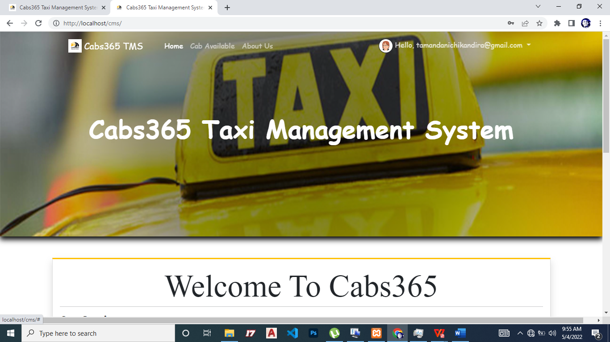

Figure 35: Homepage

<h1 class="">Welcome to <?php echo $_settings->info('name') ?></h1>

<hr>

<style>

  #cover_img_dash{

    width:100%;

    max-height:50vh;

    object-fit:cover;

    object-position:bottom center;

  }

</style>

<div class="row">

          <div class="col-12 col-sm-6 col-md-3">

            <div class="info-box">

              <span class="info-box-icon bg-gradient-dark elevation-1"><i class="fas fa-copyright"></i></span>

              <div class="info-box-content">

                <span class="info-box-text">Total Categories</span>

                <span class="info-box-number">

                  <?php

                    $inv = $conn->query("SELECT count(id) as total FROM category_list where delete_flag = 0 ")->fetch_assoc()['total'];

                    echo number_format($inv);

                  ?>

                  <?php ?>

                </span>

              </div>

              <!-- /.info-box-content -->

            </div>

            <!-- /.info-box -->

          </div>

          <!-- /.col -->

          <div class="col-12 col-sm-6 col-md-3">

            <div class="info-box">

              <span class="info-box-icon bg-gradient-warning elevation-1"><i class="fas fa-car"></i></span>

              <div class="info-box-content">

                <span class="info-box-text">Total Cabs</span>

                <span class="info-box-number">

                  <?php

                    $inv = $conn->query("SELECT count(id) as total FROM cab_list where delete_flag = 0 ")->fetch_assoc()['total'];

                    echo number_format($inv);

                  ?>

                  <?php ?>

                </span>

              </div>

              <!-- /.info-box-content -->

            </div>

            <!-- /.info-box -->

          </div>

          <!-- /.col -->

          <div class="col-12 col-sm-6 col-md-3">

            <div class="shadow info-box mb-3">

              <span class="info-box-icon bg-gradient-primary elevation-1"><i class="fas fa-users"></i></span>

              <div class="info-box-content">

                <span class="info-box-text">Registered Clients</span>

                <span class="info-box-number">

                  <?php

                    $mechanics = $conn->query("SELECT sum(id) as total FROM `client_list` where delete_flag = 0 ")->fetch_assoc()['total'];

                    echo number_format($mechanics);

                  ?>

                </span>

              </div>

              <!-- /.info-box-content -->

            </div>

            <!-- /.info-box -->

          </div>

          <!-- /.col -->

          <!-- fix for small devices only -->

          <div class="clearfix hidden-md-up"></div>

          <div class="col-12 col-sm-6 col-md-3">

            <div class="shadow info-box mb-3">

              <span class="info-box-icon bg-gradient-light elevation-1"><i class="fas fa-tasks"></i></span>

              <div class="info-box-content">

                <span class="info-box-text">Pending Bookings</span>

                <span class="info-box-number">

                <?php

                    $services = $conn->query("SELECT sum(id) as total FROM `booking_list` where status = 0 ")->fetch_assoc()['total'];

                    echo number_format($services);

                  ?>

                </span>

              </div>

              <!-- /.info-box-content -->

            </div>

            <!-- /.info-box -->

          </div>

        </div>

        <hr>

    <div class="text-center">

      <img src="<?= validate_image($_settings->info('cover')) ?>" alt="System Cover" class="w-100 img-fluid img-thumnail border" id="cover_img_dash">

    </div>

* You can register a new client.

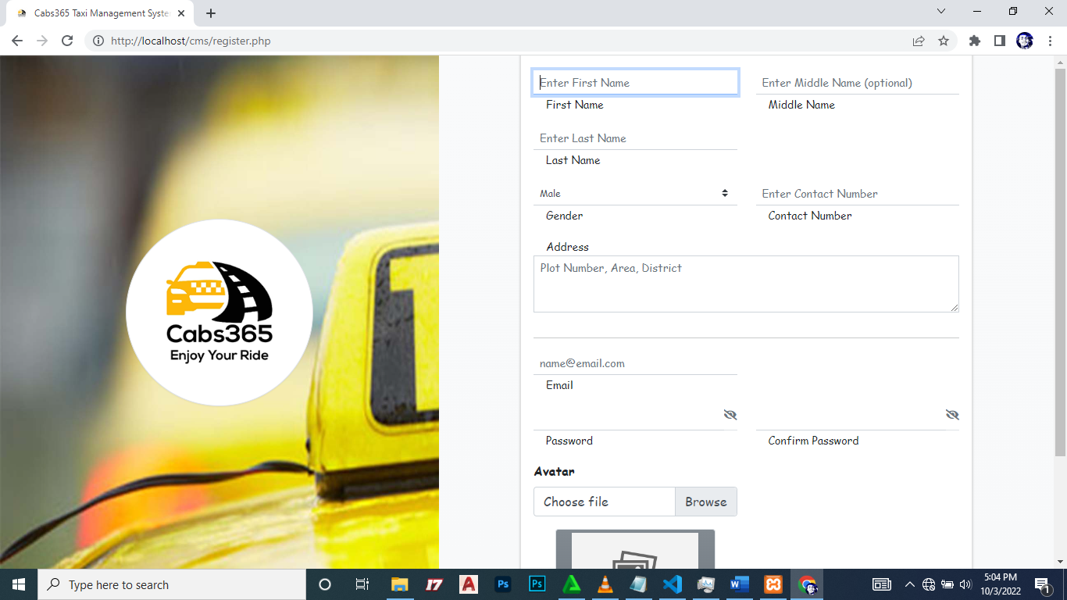

Figure 36: Client Registration

<?php require_once('./config.php') ?>

<!DOCTYPE html>

<html lang="en">

 <?php require_once('inc/header.php') ?>

<body class="">

  <script>

    start_loader()

  </script>

  <style>

    html, body{

      width:calc(100%);

      height:calc(100%);

    }

      body{

          background-image:url('<?= validate_image($_settings->info('cover')) ?>');

          background-repeat: no-repeat;

          background-size:cover;

      }

      #logo-img{

          width:15em;

          height:15em;

          object-fit:scale-down;

          object-position:center center;

      }

      #cimg{

          width:15vw;

          height:20vh;

          object-fit:scale-down;

          object-position:center center;

      }

      .pass_type{

        cursor: pointer;

      }

  </style>

<div class="d-flex align-items-center justify-content-center h-100">

  <!-- /.login-logo -->

  <div class="d-flex h-100 justify-content-center align-items-center col-lg-5">

      <center><img src="<?= validate_image($_settings->info('logo')) ?>" alt="System Logo" class="img-thumbnail rounded-circle" id="logo-img"></center>

      <div class="clear-fix my-2"></div>

  </div>

  <div class="d-flex h-100 justify-content-center align-items-center col-lg-7 bg-gradient-light text-dark">

    <div class="card card-outline card-warning w-75">

      <div class="card-header text-center">

        <a href="./" class="text-decoration-none text-dark"><b>Create an Account</b></a>

      </div>

      <div class="card-body">

      <br><br><br><br><br><br>

        <form id="register-frm" action="" method="post">

          <input type="hidden" name="id">

          <div class="row">

            <div class="form-group col-md-6">

                <input type="text" name="firstname" id="firstname" placeholder="Enter First Name" autofocus class="form-control form-control-sm form-control-border" required>

                <small class="ml-3">First Name</small>

            </div>

            <div class="form-group col-md-6">

                <input type="text" name="middlename" id="middlename" placeholder="Enter Middle Name (optional)" class="form-control form-control-sm form-control-border">

                <small class="ml-3">Middle Name</small>

            </div>

            <div class="form-group col-md-6">

                <input type="text" name="lastname" id="lastname" placeholder="Enter Last Name" class="form-control form-control-sm form-control-border" required>

                <small class="ml-3">Last Name</small>

            </div>

          </div>

          <div class="row">

            <div class="form-group col-md-6">

                  <select name="lastname" id="lastname" class="custom-select custom-select-sm form-control-border" required>

                    <option>Male</option>

                    <option>Female</option>

                  </select>

                  <small class="ml-3">Gender</small>

            </div>

            <div class="form-group col-md-6">

                <input type="text" name="contact" id="contact" placeholder="Enter Contact Number" class="form-control form-control-sm form-control-border" required>

                <small class="ml-3">Contact Number</small>

            </div>

          </div>

          <div class="row">

            <div class="form-group col-md-12">

              <small class="ml-3">Address</small>

              <textarea name="address" id="address" rows="3" class="form-control form-control-sm rounded-0" placeholder="Plot Number, Area, District"></textarea>

            </div>

          </div>

          <hr>

          <div class="row">

            <div class="form-group col-md-6">

                <input type="email" name="email" id="email" placeholder="name@email.com" class="form-control form-control-sm form-control-border" required>

                <small class="ml-3">Email</small>

            </div>

          </div>

          <div class="row">

            <div class="form-group col-md-6">

                <div class="input-group">

                  <input type="password" name="password" id="password" placeholder="" class="form-control form-control-sm form-control-border" required>

                  <div class="input-group-append border-bottom border-top-0 border-left-0 border-right-0">

                    <span class="input-append-text text-sm"><i class="fa fa-eye-slash text-muted pass_type" data-type="password"></i></span>

                  </div>

                </div>

                <small class="ml-3">Password</small>

            </div>

            <div class="form-group col-md-6">

                <div class="input-group">

                  <input type="password" id="cpassword" placeholder="" class="form-control form-control-sm form-control-border" required>

                  <div class="input-group-append border-bottom border-top-0 border-left-0 border-right-0">

                    <span class="input-append-text text-sm"><i class="fa fa-eye-slash text-muted pass_type" data-type="password"></i></span>

                  </div>

                </div>

                <small class="ml-3">Confirm Password</small>

            </div>

          </div>

          <div class="row">

            <div class="form-group col-md-6">

              <label for="" class="control-label">Avatar</label>

              <div class="custom-file">

                      <input type="file" class="custom-file-input rounded-0 form-control form-control-sm form-control-border" id="customFile" name="img" onchange="displayImg(this,$(this))">

                      <label class="custom-file-label" for="customFile">Choose file</label>

                    </div>

            </div>

          <div class="row">

          </div>

            <div class="form-group col-md-6 d-flex justify-content-center">

              <img src="<?php echo validate_image(isset($image_path) ? $image_path : "") ?>" alt="" id="cimg" class="img-fluid img-thumbnail bg-gradient-gray">

            </div>

          </div>

          <div class="row align-items-center">

            <div class="col-8">

              <a href="<?php echo base_url ?>">Back to Site</a>

            </div>

            <!-- /.col -->

            <div class="col-4">

              <button type="submit" class="btn btn-warning btn-sm btn-flat btn-block">Register</button>

            </div>

            <!-- /.col -->

          </div>

          <div class="row">

              <div class="col-12 text-center">

              <a href="<?php echo base_url.'login.php' ?>">Already have an Account?</a>

              </div>

          </div>

        </form>

        <!-- /.social-auth-links -->

        <!-- <p class="mb-1">

          <a href="forgot-password.html">I forgot my password</a>

        </p> -->

      </div>

      <!-- /.card-body -->

    </div>

    <!-- /.card -->

  </div>

</div>

<script src="<?= base_url ?>plugins/jquery/jquery.min.js"></script>

<!-- Bootstrap 4 -->

<script src="<?= base_url ?>plugins/bootstrap/js/bootstrap.bundle.min.js"></script>

<!-- AdminLTE App -->

<!-- <script src="<?= base_url ?>dist/js/adminlte.min.js"></script> -->

<script>

  window.displayImg = function(input,_this) {

      if (input.files && input.files[0]) {

          var reader = new FileReader();

          reader.onload = function (e) {

            $('#cimg').attr('src', e.target.result);

            _this.siblings('.custom-file-label').html(input.files[0].name)

          }

          reader.readAsDataURL(input.files[0]);

      }else{

            $('#cimg').attr('src', "<?php echo validate_image(isset($image_path) ? $image_path : "") ?>");

            _this.siblings('.custom-file-label').html("Choose file")

        }

  }

  $(document).ready(function(){

    end_loader();

    $('.pass_type').click(function(){

      var type = $(this).attr('data-type')

      if(type == 'password'){

        $(this).attr('data-type','text')

        $(this).closest('.input-group').find('input').attr('type',"text")

        $(this).removeClass("fa-eye-slash")

        $(this).addClass("fa-eye")

      }else{

        $(this).attr('data-type','password')

        $(this).closest('.input-group').find('input').attr('type',"password")

        $(this).removeClass("fa-eye")

        $(this).addClass("fa-eye-slash")

      }

    })

    $('#register-frm').submit(function(e){

      e.preventDefault()

      var _this = $(this)

       $('.err-msg').remove();

       var el = $('<div>')

            el.hide()

      if($('#password').val() != $('#cpassword').val()){

        el.addClass('alert alert-danger err-msg').text('Password does not match.');

        _this.prepend(el)

        el.show('slow')

        return false;

      }

      start_loader();

      $.ajax({

        url:_base_url_+"classes/Users.php?f=save_client",

        data: new FormData($(this)[0]),

                cache: false,

                contentType: false,

                processData: false,

                method: 'POST',

                type: 'POST',

                dataType: 'json',

        error:err=>{

          console.log(err)

          alert_toast("An error occured",'error');

          end_loader();

        },

        success:function(resp){

          if(typeof resp =='object' && resp.status == 'success'){

            location.href = "./login.php";

          }else if(resp.status == 'failed' && !!resp.msg){

              el.addClass("alert alert-danger err-msg").text(resp.msg)

              _this.prepend(el)

              el.show('slow')

          }else{

            alert_toast("An error occured",'error');

            end_loader();

                        console.log(resp)

          }

          $('html, body').scrollTop(0)

        }

      })

    })

  })

</script>

</body>

</html>

# Chapter 5: Project Report

I was asked to find a project topic and develop a system for the topic as a fulfilment requirement for the award of Bachelor of Commerce in Business Information Systems. I developed a web-based system that help in managing operations at Cabs365 based in Zomba, the name of the project was Cabs365 Taxi Management System (TMS).

Individual projects are virtuous in the fact that they push scholars to work hard, and to be creative. I therefore take the opportunity to thank my supervisor Mr. Kalisha who always encouraged me to think outside the box and always motivated me during the building of my system. The assessment team has also helped me shaping my ideas towards building a good system. I would also like to thank my fellow students for their support and ideas that has made this project successful.

Despite the success of the project, there were also some hiccups. The some of the problems that I faced was that of time, time was not on my side because I have other courses which were also part of the semester. My recommendation is to at least have a consistent team of assessors in all the stages of assessment. This will make it easy to follow up the problems noted in the system presentation as you know that requirements always do change.

Finally, the project gave me an insight of a real work environment scenarios as opposed to only in class environment. This will in future be useful to me and a big token of appreciation should go to Cabs365 for allowing me to conduct the project.

## Contact Details (for assistance)

E-mail: thembinkosichikandira@gmail.com

Phone numbers: (+265) 99 235 7357 / (+265) 88 604 0887

# Appendix

All work pertaining to the development of this project is done by **Thembinkosi M. Chikandira**, a Bachelor of Commerce in Business Information Systems (BIS) student, as a fulfilment requirement for the award of Bachelor of Commerce in BIS.

# References

Berrios, J. (2010). How to Install Wamp server for Windows. 2 11. http://www.wikihow.com/Install-Wamp-for-Windows (accessed 02 18, 2022).

Booz, A.H., (2003) ACT Transport Demand Elasticities Study, Report for Department of Urban Services, ACT, Australia.

Flores-Guri, D. (2003) An economic analysis of regulated taxicab markets, Review of Industrial Organization.

Frankena, M.W. and Pautler, P.A. (1984) An Economic Analysis of Taxicab Regulation, US Federal Trade Commission, Bureau of Economics Staff Report